


St.Joseph College of Engineering and Technology
As Nager Elupatti Thanjavur

A.S Nagar

Team ID: SWTID-2026-8290
Team Size: 4
Team Leader: Neethimani L
Team member: Mohamedajmal J
Team member: Hariharan R
Team member: Murthi V

WhatNext Vision Motors: Automotive Innovation And Smart Vehicle Systems

Automotive Innovation and Smart Vehicle Systems
1. Definition
Automotive Innovation and Smart Vehicle Systems is a technology-based field that focuses on developing modern vehicles using Artificial Intelligence (AI), the Internet of Things (IoT), sensors, automation, electric vehicle technology, and intelligent software systems. These technologies help improve vehicle safety, performance, fuel efficiency, comfort, and environmental sustainability.
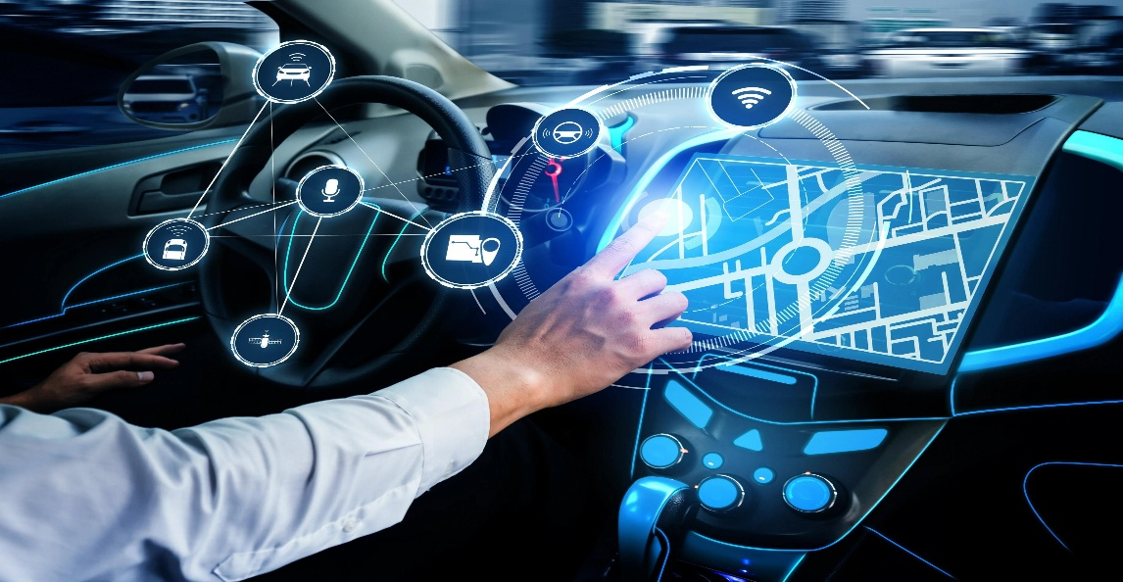

INTRODUCTION

Project Overview :
- The main purpose of this project is to design and develop an intelligent vehicle system that uses modern technologies to improve driving safety, vehicle performance, and user experience.
- The key objectives are:
- To improve vehicle safety using sensors and AI.
- To monitor vehicle health and performance in real time.
- To detect accidents and provide emergency alerts.
- To support smart parking and driver assistance.
- To reduce fuel consumption and environmental pollution.
- To integrate connected vehicle technology using IoT.
- To provide a user-friendly mobile or web application.

Uses cameras, radar, and sensors to detect obstacles, warn drivers, and assist with lane keeping and collision prevention.
- Advanced Driver Assistance System (ADAS)
Uses cameras, radar, and sensors to detect obstacles, warn drivers, and assist with lane keeping and collision prevention.

2. Smart Vehicle Monitoring
Monitors vehicle speed, engine status, temperature, battery condition, and maintenance requirements.
3. Electric Vehicle Technology
Supports battery monitoring, charging management, energy efficiency, and electric vehicle performance analysis.
4. GPS and IoT Connectivity
Provides vehicle location tracking, route navigation, remote monitoring, and connected services.
5. Accident Detection and Emergency Alerts
Detects possible accidents using sensors and sends alerts with vehicle location to designated emergency contacts.

Purpose :

Purpose of Automotive Innovation and Smart Vehicle Systems
The main purpose of Automotive Innovation and Smart Vehicle Systems is to develop advanced vehicle technologies that improve safety, efficiency, performance, and driving experience through Artificial Intelligence (AI), the Internet of Things (IoT), sensors, and automation.

Objectives :
Vehicle Safety: To improve road safety through obstacle detection, collision warnings, and driver assistance.
Smart Monitoring: To monitor vehicle speed, engine condition, battery status, and overall performance in real time.
Accident Detection: To detect potential accidents and send emergency notifications with location details.
Predictive Maintenance: To identify possible vehicle problems early and reduce unexpected breakdowns.
Fuel and Energy Efficiency: To improve fuel usage and support efficient electric vehicle operation.
GPS Tracking: To provide real-time vehicle location tracking and navigation.
Environmental Protection: To reduce unnecessary fuel consumption and vehicle emissions.
User Convenience: To provide smart features through mobile applications and connected vehicle systems.

IDEATION PHASE

Automotive Innovation and Smart Vehicle Systems

1.1 Introduction

The ideation phase is the first stage of the project development process. In this phase, ideas are generated, analyzed, and selected to solve existing problems in the automotive industry.

Bb The main focus is on identifying vehicle-related challenges and developing innovative solutions using modern technologies such as Artificial Intelligence (AI), the Internet of Things (IoT), sensors, automation, and cloud computing.

The project Automotive Innovation and Smart Vehicle Systems aims to develop an intelligent vehicle system that improves road safety, vehicle performance, maintenance, and user convenience.

  - Problem Identification
Traditional vehicles may face several challenges, including unexpected mechanical failures, road accidents, inefficient fuel consumption, limited real-time monitoring, and difficulties in vehicle tracking. Drivers may not receive early warnings about vehicle problems, which can lead to increased maintenance costs and safety risks.

Therefore, an intelligent vehicle system is needed to monitor vehicle conditions, provide alerts, and support safer and more efficient transportation.

Idea Generation
During this phase, several innovative ideas are considered for developing the proposed system.
Smart Vehicle Monitoring: Monitor vehicle speed, engine temperature, battery status, and other important parameters.

Accident Detection: Identify possible accidents and send emergency alerts to registered contacts.
AI-Based Driver Assistance: Provide warnings about obstacles, lane departure, and potential collisions.
Predictive Maintenance: Analyze vehicle data to identify possible mechanical problems before failure.
GPS Vehicle Tracking: Track vehicle location and provide navigation information.
Smart Parking: Help drivers identify available parking spaces.
Fuel and Battery Management: Monitor fuel consumption and electric vehicle battery performance.

Proposed Solution
The proposed solution is to develop a smart vehicle system that integrates AI, IoT, GPS, and sensor technologies. The system collects vehicle data, processes the information, and provides useful notifications through a mobile or web application.

The system may include a dashboard displaying vehicle status, maintenance reminders, location tracking, and safety alerts. Depending on the project scope, a hardware prototype can also be developed using sensors and a microcontroller.

TECHNOLOGY | PURPOSE
Artificial intelligence (AI) | Intelligent analysis and decision-making
Internet of things (IoT) | Real time data communication
GPS | Vehicle location tracking
Sensors | Monitoring vehicle condition
Cloud computing | Data storage and processing
Machine Learning (ML) | Predictive maintenance analysis
Web/Mobile Application | Displaying vehicle information alerts

Feasibility Analysis
Technical Feasibility: The project can be developed using available software tools, sensors, GPS modules, and IoT platforms.
Economic Feasibility: A basic prototype can be developed with affordable hardware and open-source software.
Operational Feasibility: The system can provide a user-friendly interface for drivers and vehicle owners to monitor vehicle information.
Environmental Feasibility: The project can support efficient fuel usage, battery monitoring, and reduced unnecessary vehicle operation.

Empathy Map Canvas
Automotive Innovation and Smart Vehicle Systems

An Empathy Map Canvas is a design-thinking tool used to understand the needs, feelings, thoughts, and challenges of users. It helps project developers understand the problems faced by drivers, vehicle owners, mechanics, and passengers.
For the Automotive Innovation and Smart Vehicle Systems project, the empathy map focuses on understanding users’ expectations regarding vehicle safety, performance, maintenance, fuel efficiency, and smart technologies.
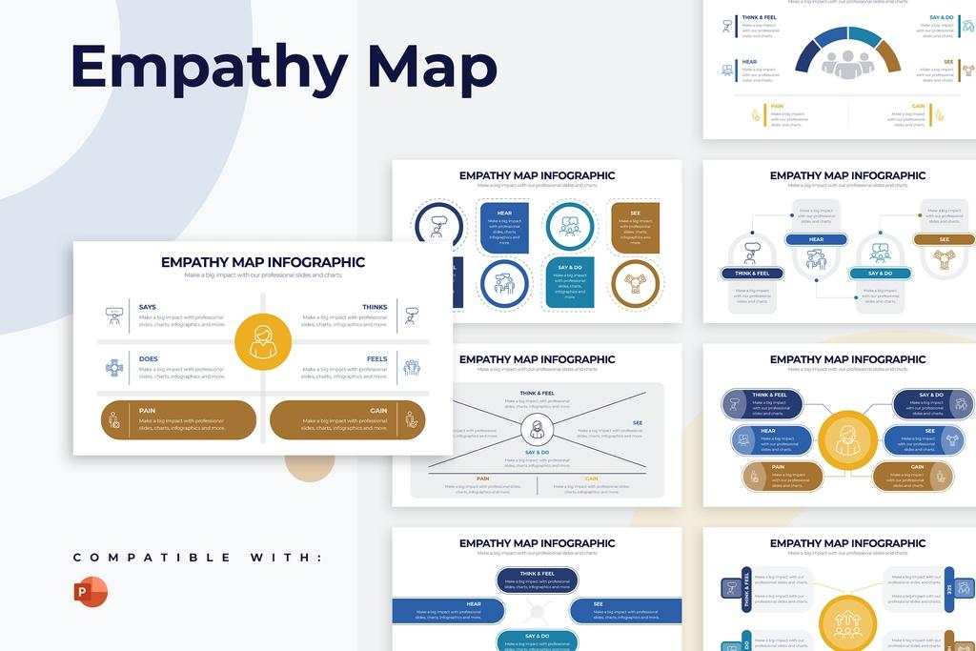

USER / CUSTOMER
Drivers, vehicle owners and passengers
- SAYS
“I need a safe and reliable vehicle.”
“I want timely maintenance alerts.”
- THINKS
Is my vehicle working properly?
How can I avoid unexpected repair costs?
- DOES
Checks vehicle performance.
Visits service centres and uses navigation apps.
- FEELS
Worried about accidents and breakdowns.
Wants comfort, safety, and confidence.
- PAINS
Unexpected breakdowns, high maintenance costs, traffic, limited vehicle information, and safety concerns.
- GAINS
Real-time monitoring, early warnings, lower maintenance costs, better safety, and efficient vehicle operation.
Says
Users express their needs and expectations about smart vehicles. They want reliable transportation, timely notifications, improved safety, and easy access to vehicle information.

Thinks
Users think about vehicle condition, repair expenses, fuel consumption, battery performance, accident prevention, and the reliability of smart vehicle technology.

Does
Users regularly drive vehicles, check fuel levels, monitor dashboard warnings, schedule vehicle servicing, use GPS navigation, and contact mechanics when problems occur.

Feels
Users may feel concerned about unexpected breakdowns, road accidents, traffic congestion, and costly repairs. They feel more confident when they have access to reliable vehicle information.

Pains
The major problems experienced by users include:
Unexpected mechanical failures.
Expensive maintenance and repair.
Lack of real-time vehicle monitoring.
Difficulty identifying vehicle faults early.
Road safety concerns.
Inefficient fuel or battery usage.

Gains
Users expect the following benefits from the proposed system:
Improved driving safety.
Real-time vehicle health monitoring.
Early fault detection and maintenance reminders.
GPS tracking and navigation support.
Reduced unnecessary repair expenses.
Improved fuel and battery efficiency.

Brainstorming & Idea Prioritization

Brainstorming and Idea Prioritization is an important stage in the design thinking and project development process. Brainstorming involves generating multiple ideas to solve identified problems, while idea prioritization involves evaluating and selecting the most suitable ideas based on their importance, feasibility, cost, and expected benefits.

In the Automotive Innovation and Smart Vehicle Systems project, this phase focuses on identifying innovative automotive solutions using Artificial Intelligence (AI), the Internet of Things (IoT), GPS, sensors, and smart software applications.

Objectives of Brainstorming
The main objectives of brainstorming are:
To identify common problems faced by drivers and vehicle owners.
To generate innovative solutions for automotive challenges.
To improve vehicle safety and reliability.
To explore smart vehicle monitoring technologies.
To identify suitable AI and IoT applications.
To select feasible features for project implementation.

Brainstorming Ideas
The following ideas were generated to improve vehicle performance, safety, and user experience.
- Smart Vehicle Health Monitoring
Monitor engine temperature, battery status, vehicle speed, and other available vehicle parameters in real time.
- Accident Prevention and Detection
Use suitable sensors and cameras to identify potential hazards and provide driver warnings.
- Predictive Maintenance
Analyze vehicle diagnostic information to identify possible faults and recommend maintenance.
- GPS Tracking System
Provide vehicle location information, route tracking, and location sharing.
- Smart Fuel and Battery Management
Track fuel usage or battery status and provide efficiency information.
- Smart Parking Assistance
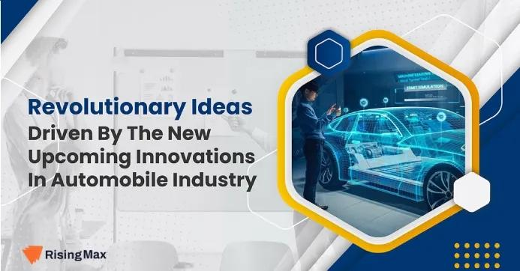
Help drivers identify available parking spaces using sensors or parking availability data

REQUIREMENT ANALYSIS PHASE

Customer Journey Map
Stages:
    - Inquiry → Vehicle Selection → Order Placement → Dealer Assignment → Stock Valida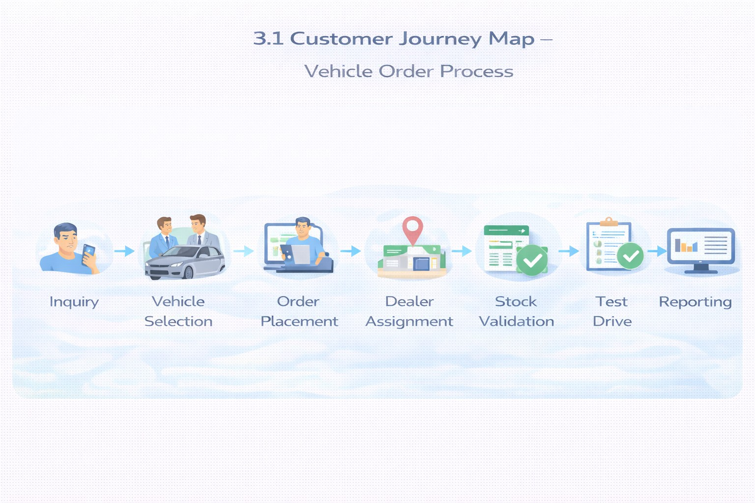tion → Test Drive → Confirmation → Reporting

Solution Requirements
Functional Requirements

FR No | Requirement
FR-1 | Vehicle management
FR-2 | Dealer management
FR-3 | Customer order creation
FR-4 | Stock validation
FR-5 | Dealer auto-assignment

FR-6 | Test drive scheduling
FR-7 | Reports & dashboards

Non-Functional Requirements

NFR | Description
Usability | Lightning UI for easy navigation
Security | Role-based access control
Reliability | Accurate automation
Performance | Fast order processing
Availability | 24/7 cloud access
Scalability | Multi-dealer support

Data Flow Diagram
Flow:
Customer Input → Order Creation → Stock Validation → Dealer Assignment → Status Update → Reports
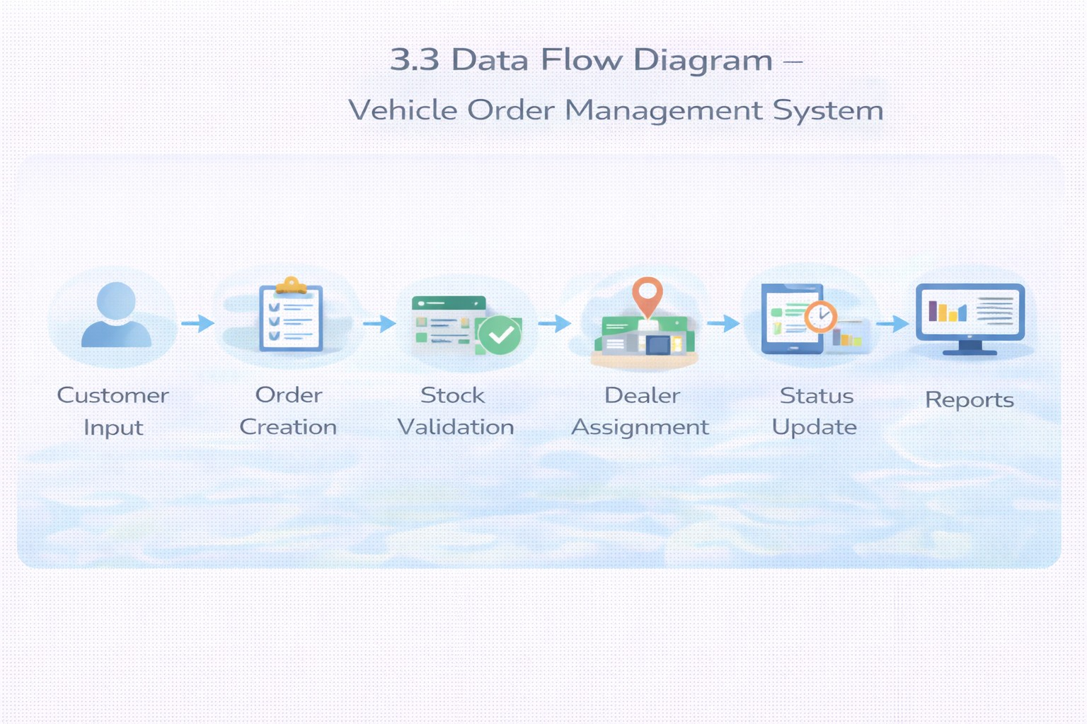

Technology Stack

Layer | Technology
UI | Salesforce Lightning
Logic | Salesforce Flows
Database | Salesforce Objects
Automation | Validation Rules, Triggers
Processing | Batch Apex, Scheduled Apex
Reporting | Reports & Dashboards

PROJECT DESIGN PHASE

Problem–Solution Fit
The system eliminates fragmented operations by integrating automated stock validation, dealer assignment, and order processing within Salesforce.
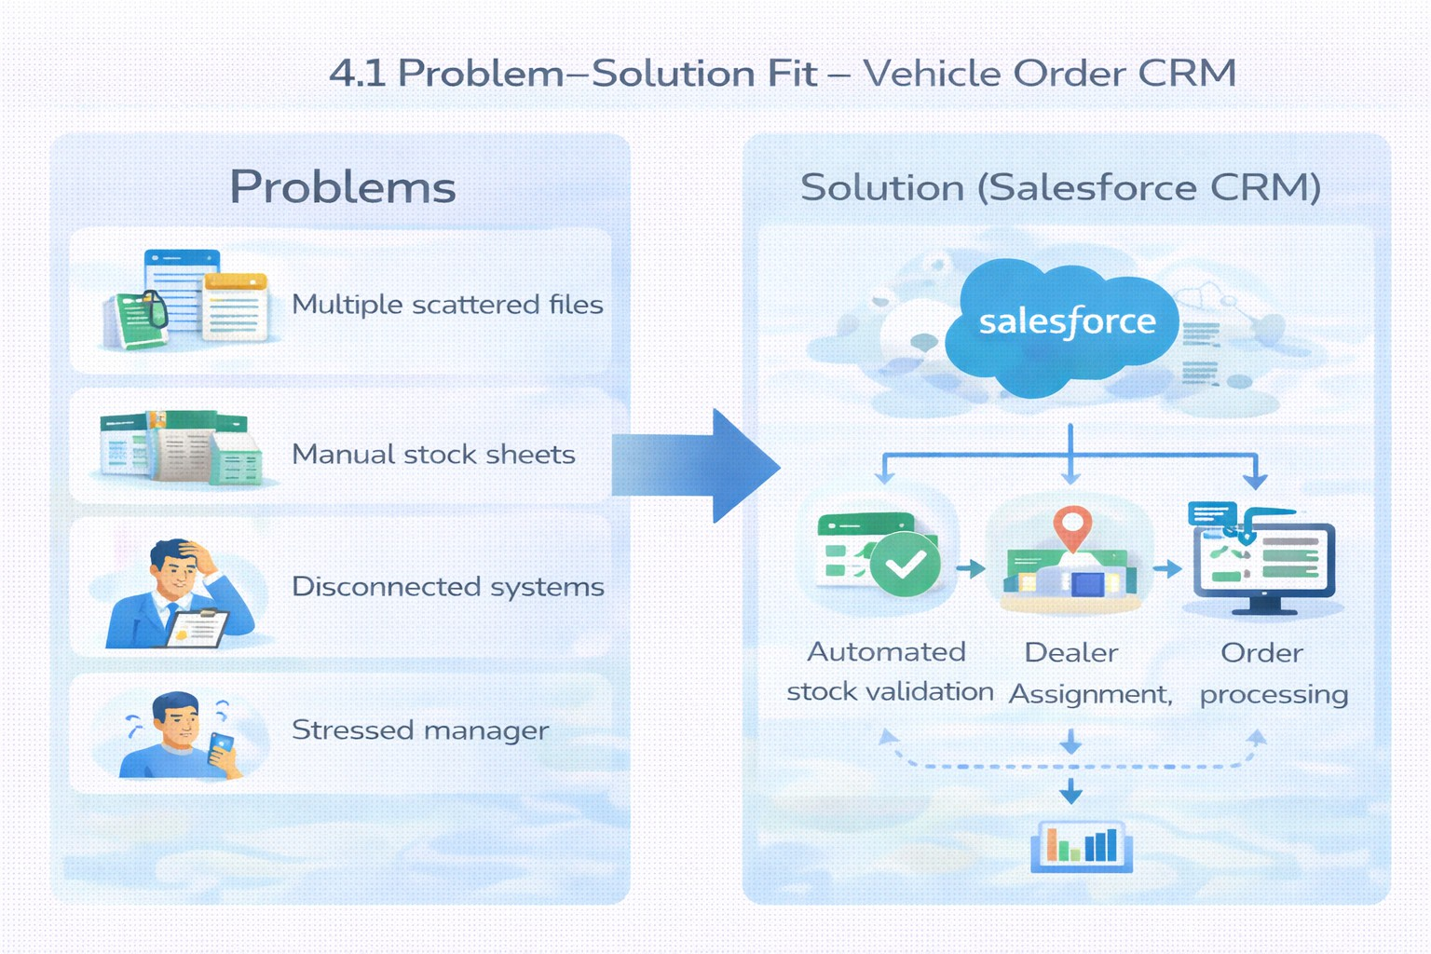

Proposed Solution
Functional Requirements

Parameter | Description

Problem | Manual vehicle ordering
Solution | Salesforce CRM
Innovation | Automated dealer assignment
Impact | Faster service
Business Model | Dealer network
Scalability | Multi-location support

Solution Architecture
Components:
    - Vehicle Object
    - Dealer Object
    - Customer Object
    - Order Object
    - Test Drive Object
    - Service Request Object
    - Flows
    - Apex Triggers
    - Batch Jobs
    - Reports
    - Dashboards

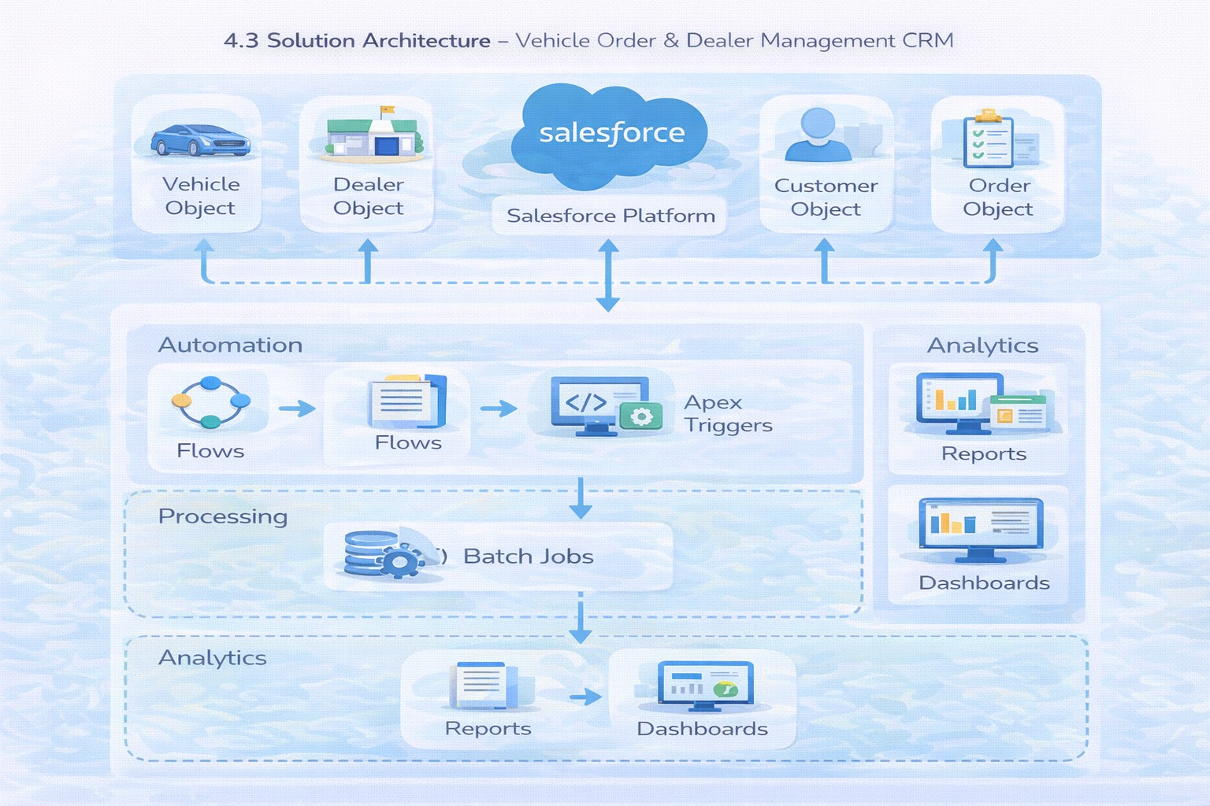

PROJECT PLANNING & SCHEDULING

Project Planning
    - Agile methodology
    - Epics → Stories → Story Points
    - Sprint-based execution
    - Velocity calculation used for estimation
Product Backlog, Sprint Schedule, and Estimation (4 Marks)
Use the below template to create product backlog and sprint schedule

Sprint | Functional Requirement (Epic) | User Story Number | User Story / Task | Story Points | Priority | Team Member s
Sprint-1 | Developer Setup | USN-1 | As a system administrator, I want to create and configure a Salesforce developer account so that I can build and deploy the vehicle order management system. | 3 | High | Member1
Sprint-2 | Data Modeling | USN-2 | As an admin, I want to create  Vehicle, Dealer, Customer, Order, | 5 | High | Member2

Sprint | Functional Requirement  (Epic) | User Story  Number | User Story / Task | Story Points | Priority | Team Member  s
 |  |  | and Service Request objects with proper relationships so that all business data is stored and managed systematically.
Sprint-2 | Data Modeling | USN-3 | As a staff member, I want dedicated tabs and a Lightning App for all modules so that I can easily navigate and manage vehicle  orders and dealer operations. | 5 | High | Member3
Sprint-3 | Automation | USN-4 | As a system, I want to validate stock availability, mandatory fields, and order inputs so that invalid or incomplete vehicle orders are prevented. | 3 | High | Member4
Sprint-3 | Automation | USN-5 | As a sales coordinator, I want automated flows to assign the nearest dealer and update order status so that processing becomes faster and requires minimal manual  effort. | 3 | High | Member4
Sprint-4 | Apex | USN-6 | As a system, I want Apex triggers to automatically perform actions such as order confirmation and dealer assignment so that critical processes occur instantly and accurately. | 5 | High | Member1
Sprint-4 | Apex | USN-7 | As an inventory manager, I want batch jobs to update vehicle stock levels automatically so that inventory data remains accurate  and up to date. | 5 | High | Member2
Sprint-5 | Reports | USN-8 | As a manager, I want reports showing order status, dealer performance, and sales metrics so that I can monitor operations and make informed decisions. | 4 | High | Member3
Sprint-6 | Dashboards | USN-9 | As a manager, I want dashboards showing order status, dealer performance, and sales metrics so that I can monitor operations and  make informed decisions. | 4 | Medium | Member4

Project Tracker, Velocity & Burndown Chart: (4 Marks)

Sprint | Total Story Points | Duratio n | Sprint Start Date | Sprint End Date (Planned) | Story Points Completed (as on Planned End  Date) | Sprint Release Date (Actual)
Sprint-1 | 20 | 6 Days | 24 Oct 2022 | 29 Oct 2022 | 20 | 29 Oct 2022
Sprint-2 | 20 | 6 Days | 31 Oct 2022 | 05 Nov 2022
Sprint-3 | 20 | 6 Days | 07 Nov 2022 | 12 Nov 2022
Sprint-4 | 20 | 6 Days | 14 Nov 2022 | 19 Nov 2022

Project Development Phase:

The Project Development Phase for the WhatNext Vision Motors CRM involves the hands-on configuration, automation, and coding within the Salesforce Developer Org to bring the system architecture to life.
For this specific Salesforce-based automotive CRM, the development phase is broken down into the following core technical stages:
1. Environment Setup&Data Modeling
Org Initialization: Setting up the Salesforce Developer Edition environment where all configurations and code will reside.
Custom Objects & Fields: Creating the foundational database tables (e.g., Vehicle__c, Dealer__c, Customer_Order__c, Test_Drive__c, Service_Request__c) and their specific fields (data types, picklists, formulas).
Relationships: Establishing Lookup and Master-Detail relationships to link data—such as connecting a specific Customer_Order__c to both a Vehicle__c and a Dealer__c.
2. Business Logic&Automation (Backend)
Salesforce Flows: Building screen flows and record-triggered flows to automate routine tasks, such as generating automated email confirmations for test drives or updating service request statuses.
Apex Triggers & Classes: Writing custom Apex code to handle complex backend logic that declarative tools cannot. This includes programming the trigger that checks live inventory and explicitly blocks an order from saving if the selected vehicle is out of stock.
Automated Dealer Routing: Developing the logic (via Apex or complex Flows) that reads a customer’s postal code or address and automatically assigns their order to the nearest localized dealer.
3. User Interface (UI) Development (Frontend)
Lightning App Creation: Building the overarching “WhatNext Vision Motors” Lightning Application to house all relevant tabs and navigation menus in one place.
Page Layouts & Lightning Record Pages: Customizing how data is displayed to the user, ensuring that sales reps and admins see only the most relevant fields when viewing a vehicle or customer profile.
Lightning Web Components (LWC): Developing custom code-based interface components for highly specific UI requirements that standard Salesforce layouts do not support.
4. Security&Access Control
Organization-Wide Defaults (OWD): Setting baseline privacy levels for customer and dealership data.
Profiles & Permission Sets: Creating tailored access levels for different users (e.g., ensuring a Dealership Manager can approve orders while a Service Technician can only view service requests).
5. Analytics Configuration
Custom Reports: Building backend reports to aggregate data on daily sales, pending orders, and current inventory levels.
Real-Time Dashboard Design: Connecting those reports to a visual, centralized Lightning Dashboard so management can monitor the order fulfillment rate, total revenue, and stock depletion metrics live.

What you'll learn

- Data Modelling
- Fields and Relationships
- Lightning App Builder
- Record Triggered Flows
- Apex and Apex Triggers
- Batch Apex
- Scheduled Apex

Milestone 1: Salesforce Account

Activity 1: Creating Developer Account
Creating a developer org in salesforce.
- Go to https://developer.salesforce.com/signup
- On the sign up form, enter the following details :

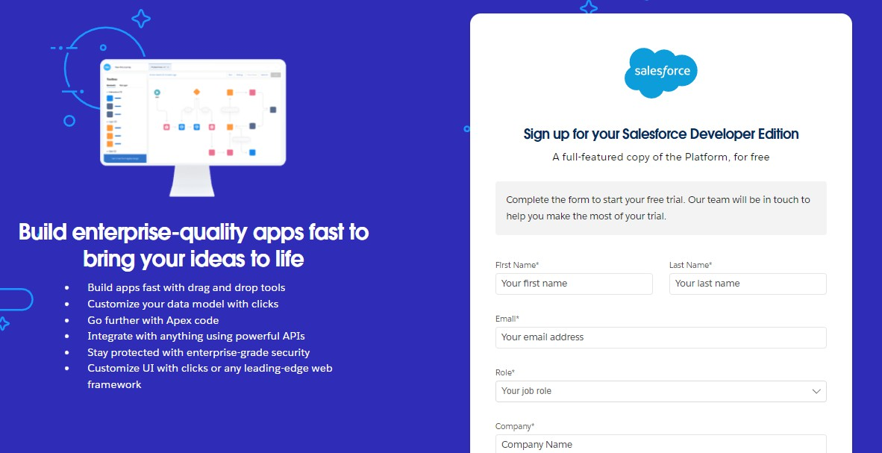
  - First name & Last name
  - Email
  - Role : Developer
  - Company : College Name
  - County : India
  - Postal Code : pin code
  - Username : should be a combination of your name and company This need not be an actual email id, you can give anything in the format : username@organization.com
Click on sign me up after filling these.

Activity 2: Account Activation
- Go to the inbox of the email that you used while signing up. Click on the verify account to activate your account. The email may take 5-10mins.

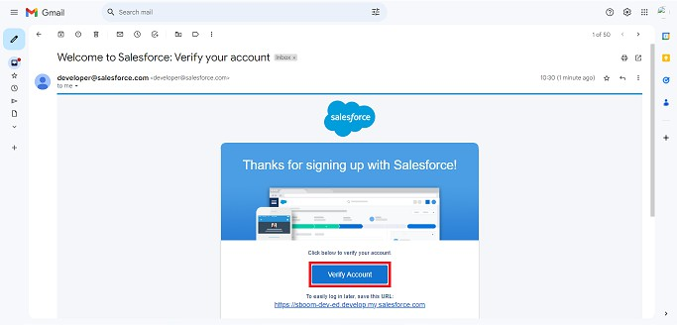
- Click on Verify Account
- Give a password and answer a security question and click on change password.

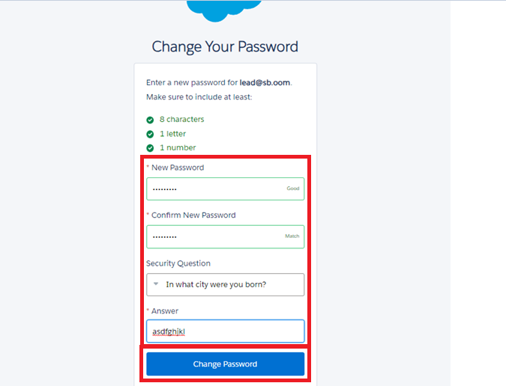
- Then you will redirect to your salesforce setup page.

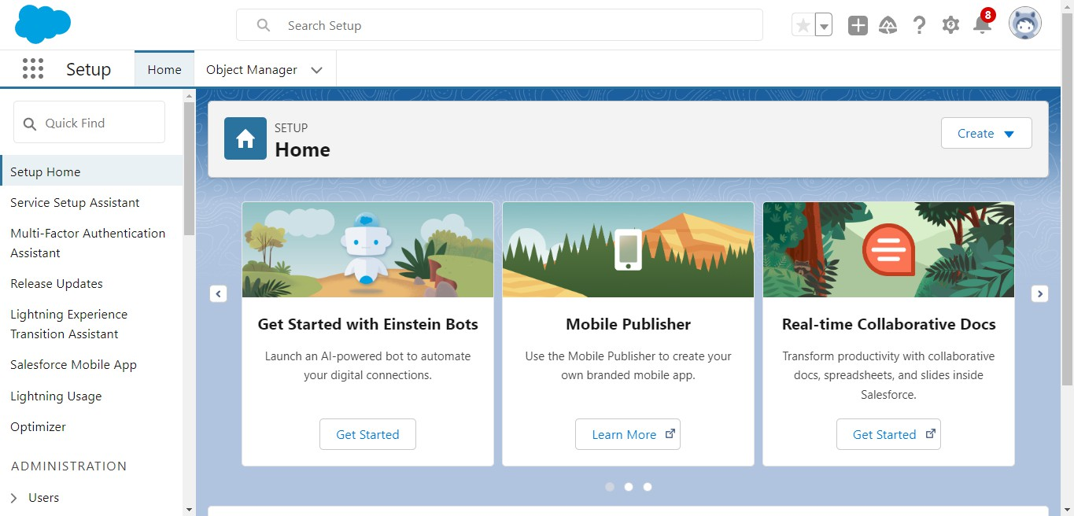

Milestone 2: Data Management-Objects

Objects & Relationships

Object Name | Purpose | Relationships
Vehicle c | Stores vehicle details | Related to Dealer & Orders
Vehicle_Dealer c | Stores authorized dealer info | Related to Orders
Vehicle_Customer c | Stores customer details | Related to Orders & Test Drives
Vehicle_Order c | Tracks vehicle purchases | Related to Customer & Vehicle

Vehicle_Test_Drive c | Tracks test drive bookings | Related to Customer & Vehicle
Vehicle_Service_Reques t c | Tracks vehicle servicing requests | Related to Customer & Vehicle

To Navigate to Setup page:

Click on gear icon → click setup.
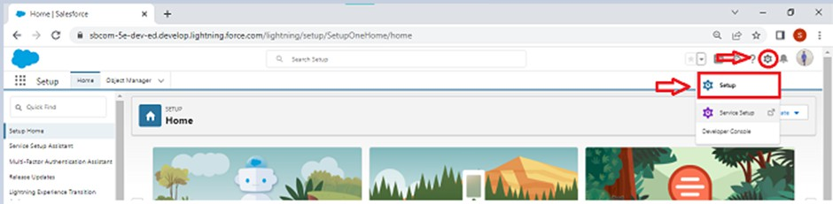

Activity 1: Create Vehicle Object

The purpose of creating a Vehicle custom object is to have a clear picture of the vehicle details.
To create an object:
- From the setup page → Click on Object Manager → Click on Create → Click on Custom Object.

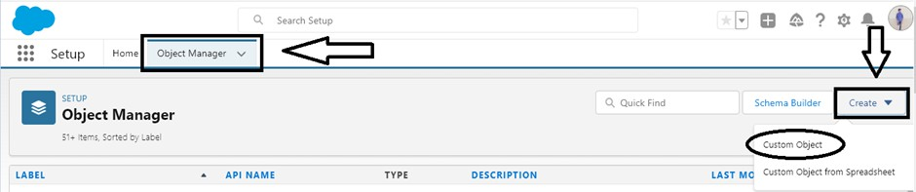
  - Enter the label name→ Vehicle
  - Plural label name→ Vehicles
  - Enter Record Name Label and Format
    - Record Name → Vehicle Name
    - Data Type → Text
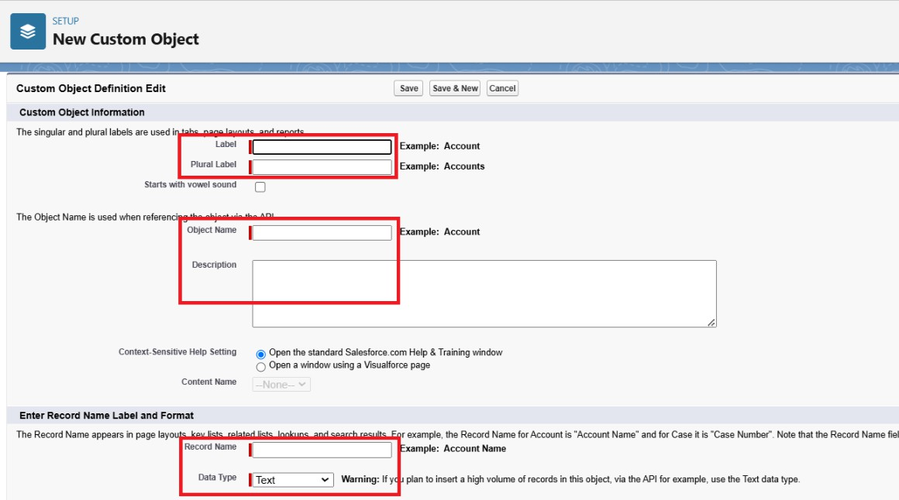
- Click on Allow reports,
- Allow search → Save.

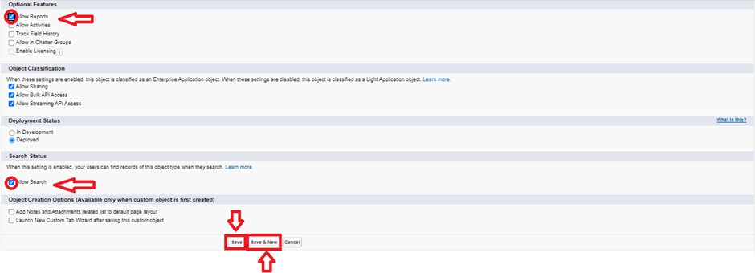

Activity 2: Create Dealer Object

The purpose of creating a Dealer object is to have detailed information about Dealer. To create an object:
- From the setup page → Click on Object Manager → Click on Create → Click
on Custom Object.
  - Enter the label name→ Vehicle Dealer
  - Plural label name→ Vehicle Dealers
  - Enter Record Name Label and Format
    - Record Name → Dealer Name
    - Data Type → Text
- Click on Allow reports,
- Allow search → Save

Activity 3: Creating remaining objects

Creating remaining objects

Create remaining objects which have mentioned in the above table Data Management-Objects

Milestone 3: Data Management-Tabs

Activity 1: Creating a Custom Tab(Vehicle)

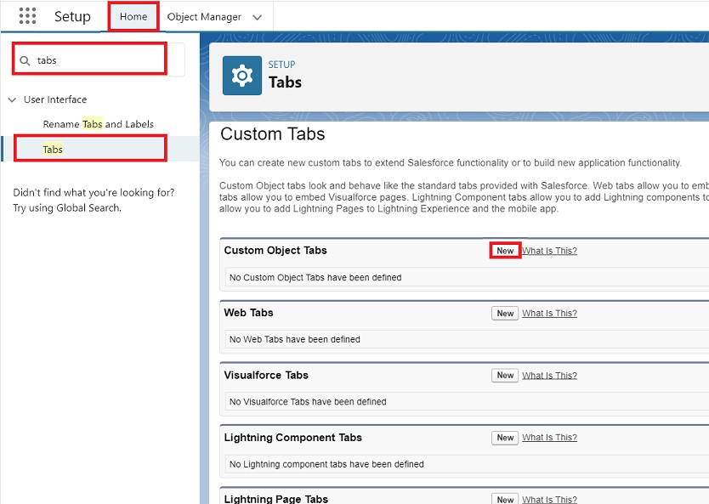
- Go to setup page → type Tabs in Quick Find bar → click on tabs → New (under custom object tab)
- Select Object(Vehicle) → Select any tab style → Next (Add to profiles page) keep it as default → Next (Add to Custom App) keep it as default → Save.

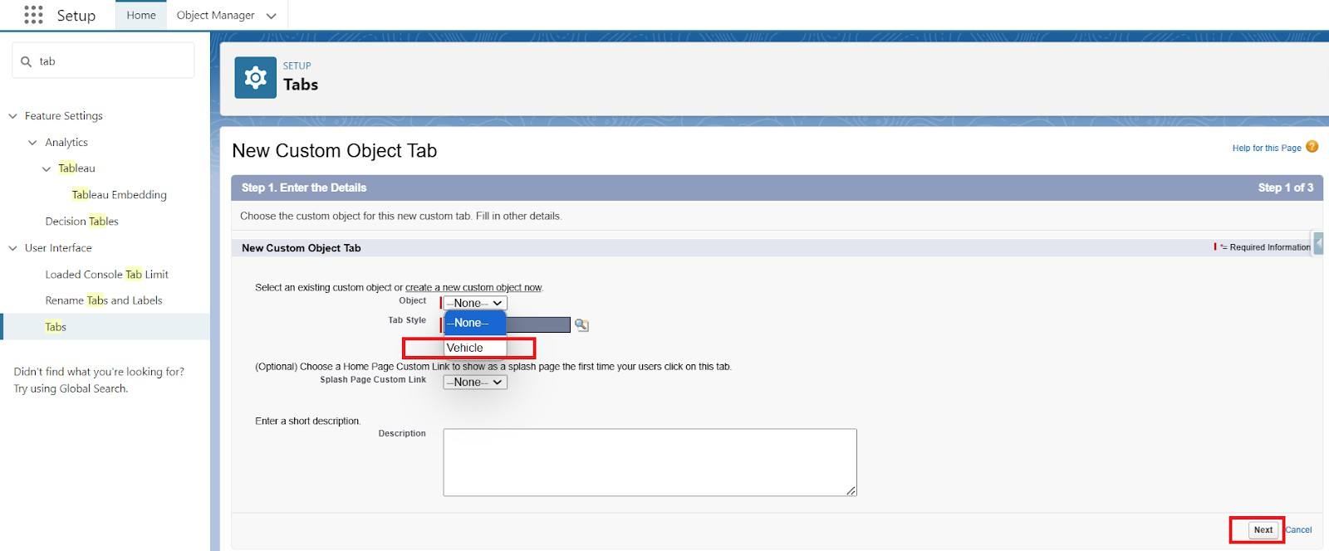

Activity 2:
Now create tabs for Other objects as well which we have created above Objects.

Milestone 4: Data Management-App Manager

Activity 1: Create a Lightning App To create a lightning app page:
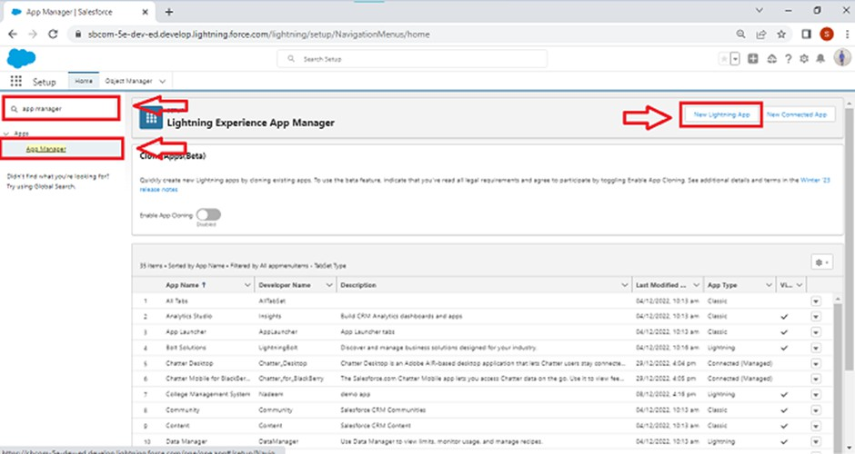
- Go to setup page → search “app manager” in quick find → select “app manager” → click on New lightning App.

- Fill the app name in app details and branding as follow App Name : WhatNext Vision Motors
Developer Name : this will auto populated Description : Give a meaningful description
Image : optional (if you want to give any image you can otherwise not mandatory) Primary color hex value : keep this default
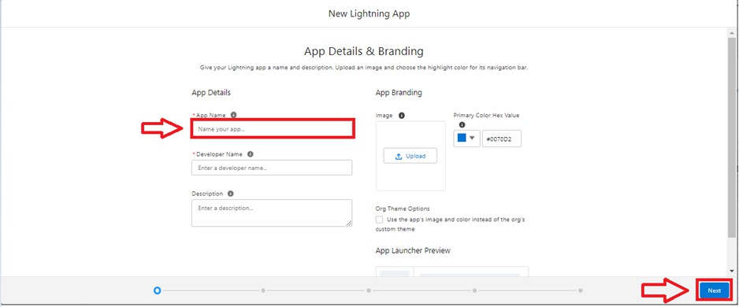
- Then click Next → (App option page) keep it as default → Next → (Utility Items) keep it as default → Next.
- To Add Navigation Items:
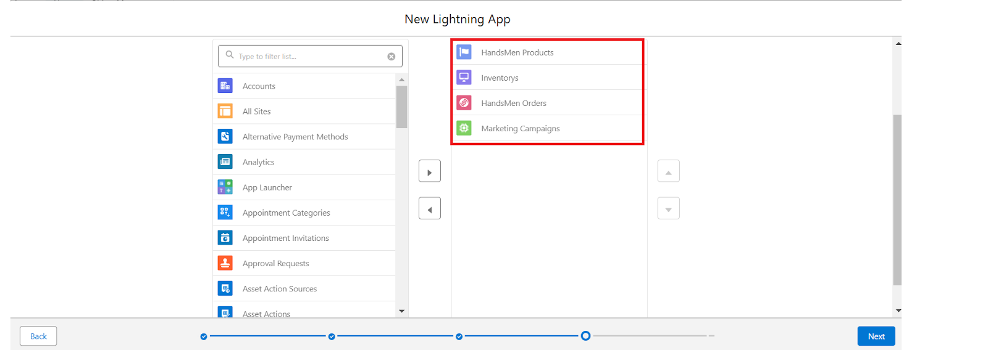
Search the items in the search bar(Vehicle, Dealer, Customer, Order, Test Drive, Service Request, Reports, Dashboard) from the search bar and move it using the arrow button → Next.
Note: select the custom object which we have created in the previous activity.

- To Add User Profiles:

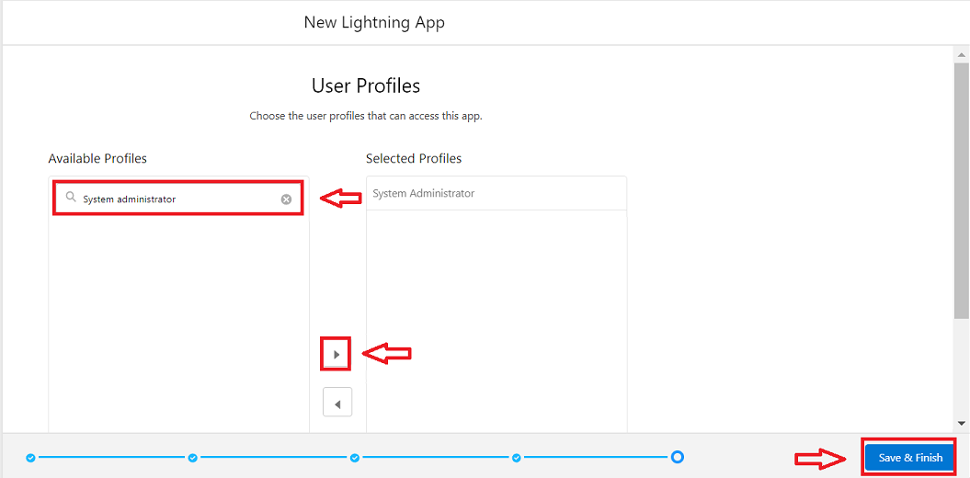

Search profiles (System administrator) in the search bar → click on the arrow button
→ save & finish.

Milestone 5: Data Management-Fields

Key Fields for Each Object

Vehicle c (Custom Object)
  - Vehicle_Name c (Text)
  - Vehicle_Model c (Picklist: Sedan, SUV, EV, etc.)
  - Stock_Quantity c (Number)
  - Price c (Currency)
  - Dealer c (Lookup to Dealer c)
  - Status c (Picklist: Available, Out of Stock, Discontinued)
- Vehicle_ Dealer c (Custom Object)
  - Dealer_Name c (Text)
  - Dealer_Location c (Text)
  - Dealer_Code c (Auto Number)
  - Phone c (Phone)
  - Email c (Email)
- Vehicle_Order c (Custom Object)

  - Customer c (Lookup to Customer c)
  - Vehicle c (Lookup to Vehicle c)
  - Order_Date c (Date)
  - Status c (Picklist: Pending, Confirmed, Delivered, Canceled)
- Vehicle_Customer c (Custom Object)
  - Customer_Name c (Text)
  - Email c (Email)
  - Phone c (Phone)
  - Address c (Text)
  - Preferred_Vehicle_Type c (Picklist: Sedan, SUV, EV, etc.)
- Vehicle_Test_Drive c (Custom Object)
  - Customer c (Lookup to Customer c)
  - Vehicle c (Lookup to Vehicle c)
  - Test_Drive_Date c (Date)
  - Status c (Picklist: Scheduled, Completed, Canceled)
- Vehicle_Service_Request c (Custom Object)
  - Customer c (Lookup to Customer c)
  - Vehicle c (Lookup to Vehicle c)
  - Service_Date c (Date)
  - Issue_Description c (Text)
  - Status c (Picklist: Requested, In Progress, Completed)

Object Field Creation :
- Go to setup → click on Object Manager → type object name(Vehicle) in quick find bar→ click on the object.
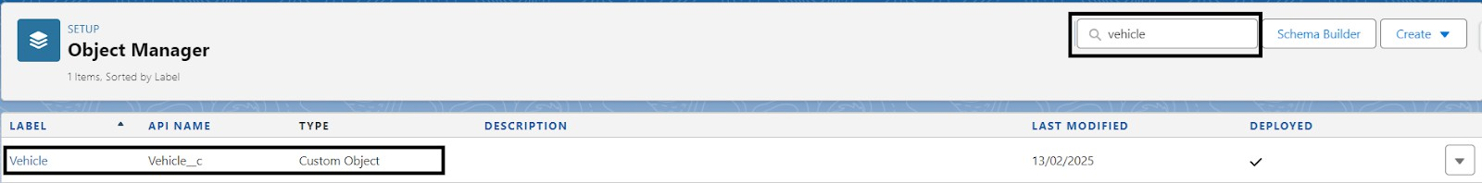
- Now click on “Fields & Relationships” → New

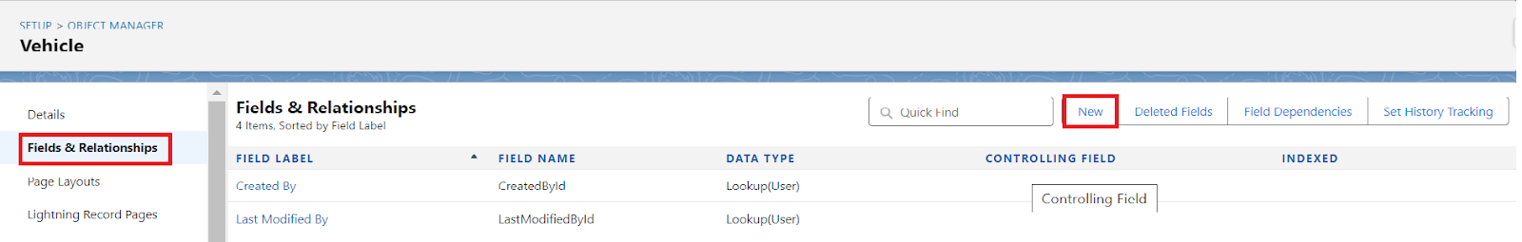
- Select Data type as “PickList”.
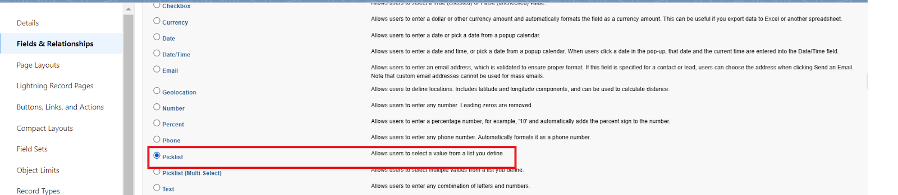

- Click on Next
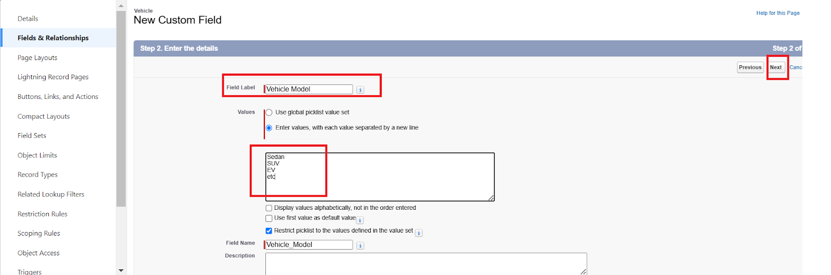
- Fill the above as following:
  - Field Label: Vehicle Modal
  - Fill PickList Values
  - Click on Next → Next → Save and new.

Object Field Creation-2 :
- Repeat the steps 1 & 2 from the activity 1
- Select Data type as “Number”.
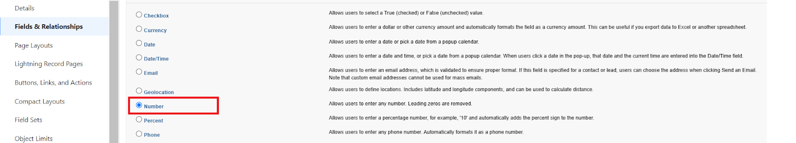

- Click on Next
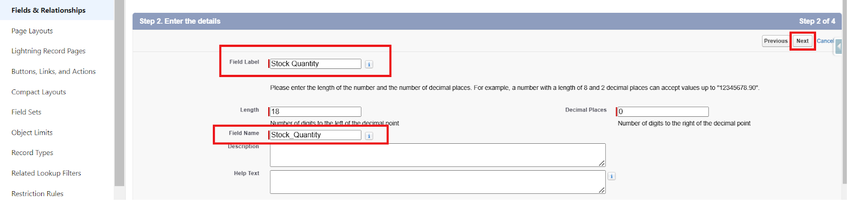

- Fill the above as following:
  - Field Label: Stock Quality
  - Click on Next → Next → Save and new.

Relationship Field Creation :

Creating a Lookup RelationShip in Vehicle Object to Dealer Object.
- Select DataType as Lookup Relationship.
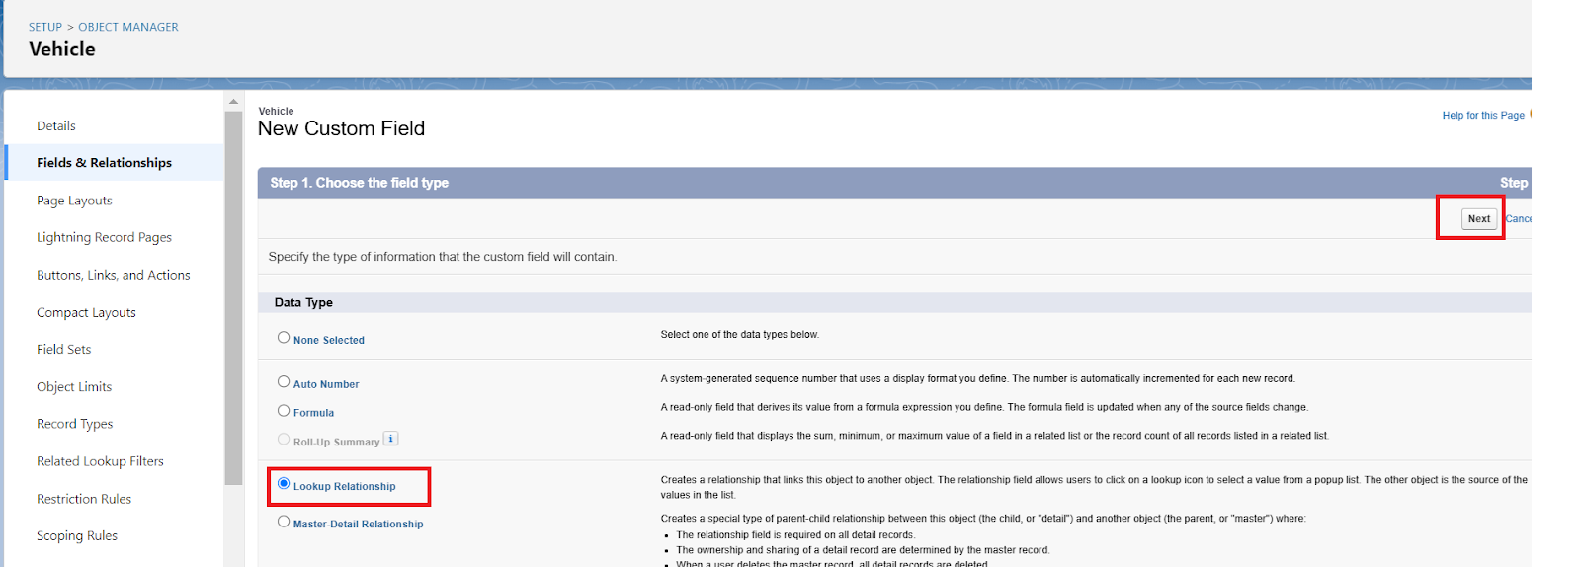

- Click Next
- Select Dealer Object Form Related Filed.
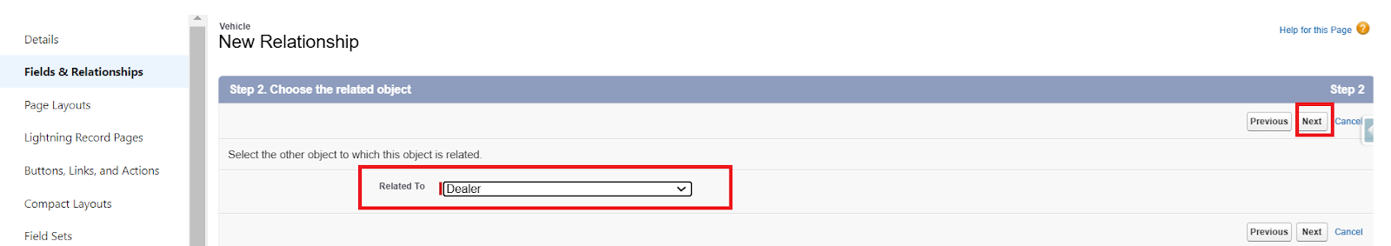

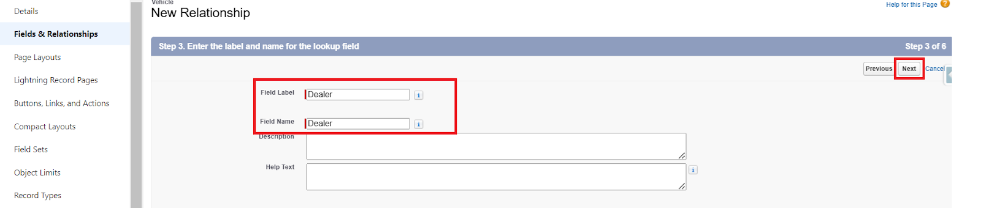
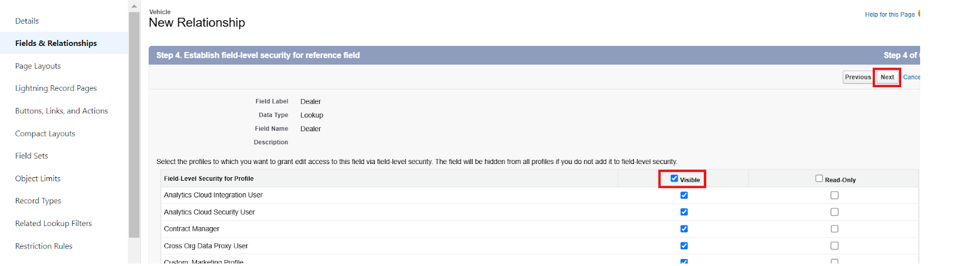

- Click Next and Save.

More Fields Creation

Create remaining fields as mentioned in the Data Management-Fields

Milestone 6: Automation

Flow Creation :

Creating a record triggered flow to assign nearest dealer to the customer’s location
Step 1 : In Quick Find, type Flows and click on Flows. Click New Flow.
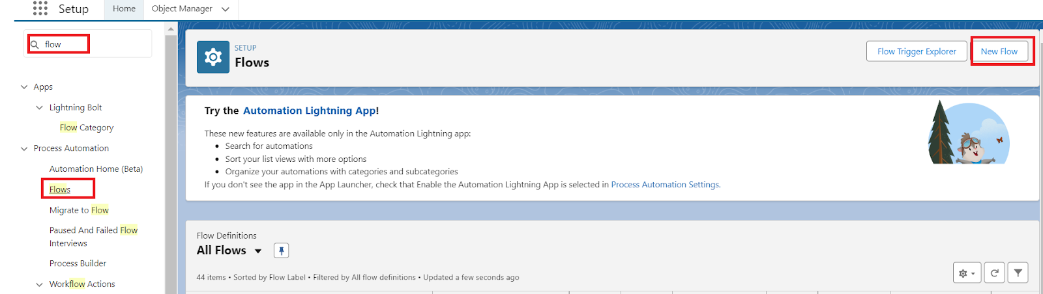

Step 2 : Select Start From Scratch and click Next.

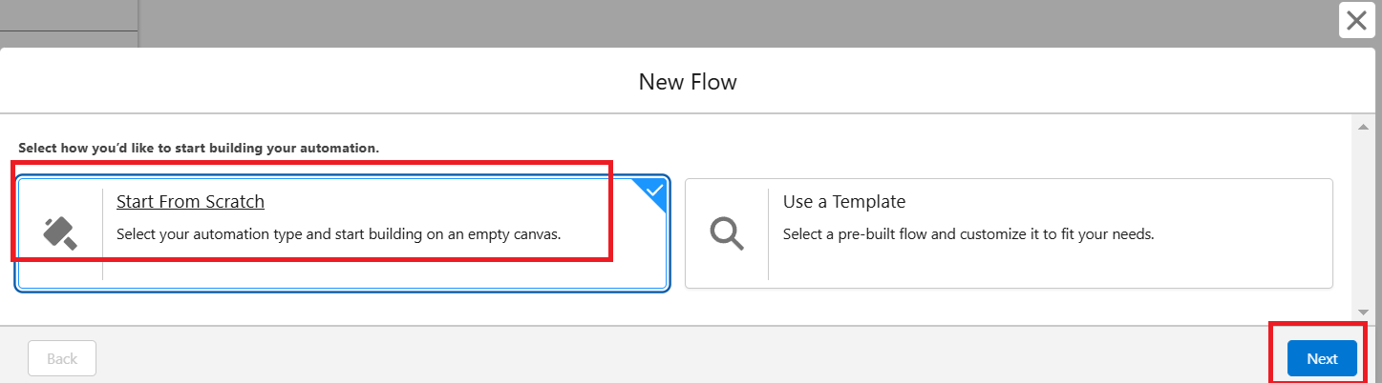

Step 3 : Select Record-Triggered Flow and click Create

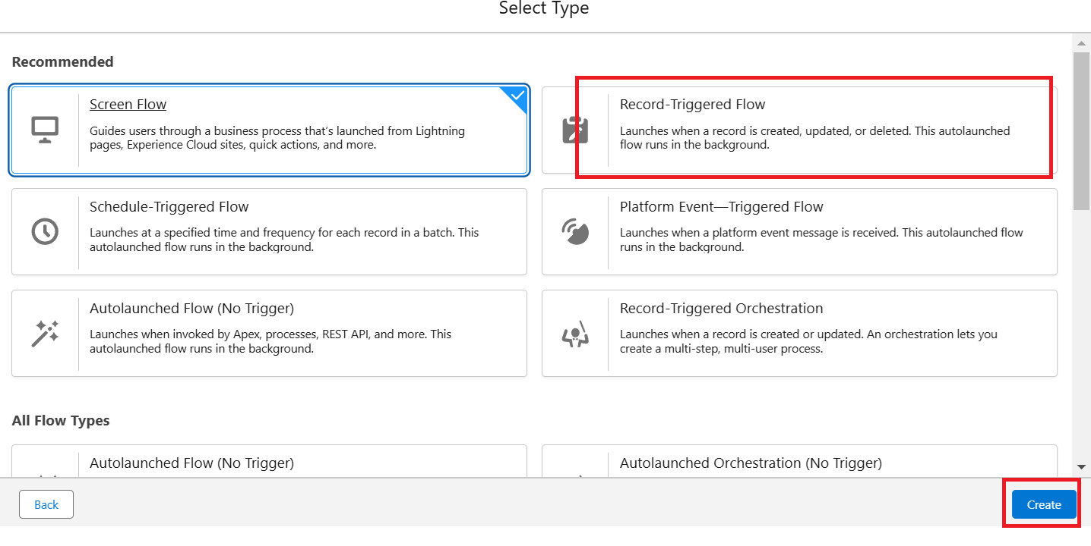

Step 4 : Select Vehicle Order Object
Trigger the Flow When : Select Record is Created.

Set Entry Condition :
All Conditions Are Met (AND) Filed : Status c
Operator : Equals Value : Pending

Step 5 : Click + → Select Get Records

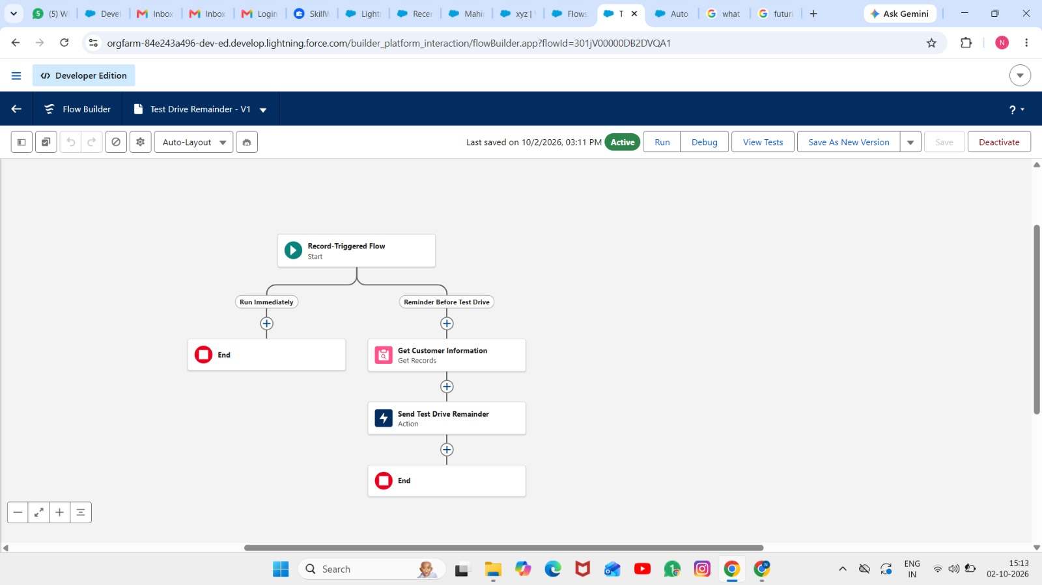
Step 6 : Label : Get Customer Information
- Object : Vehicle Customer
- Condition :
- Field : Id
- Operator : Equals
- Value : {!$Record.Vehicle_Customer c}

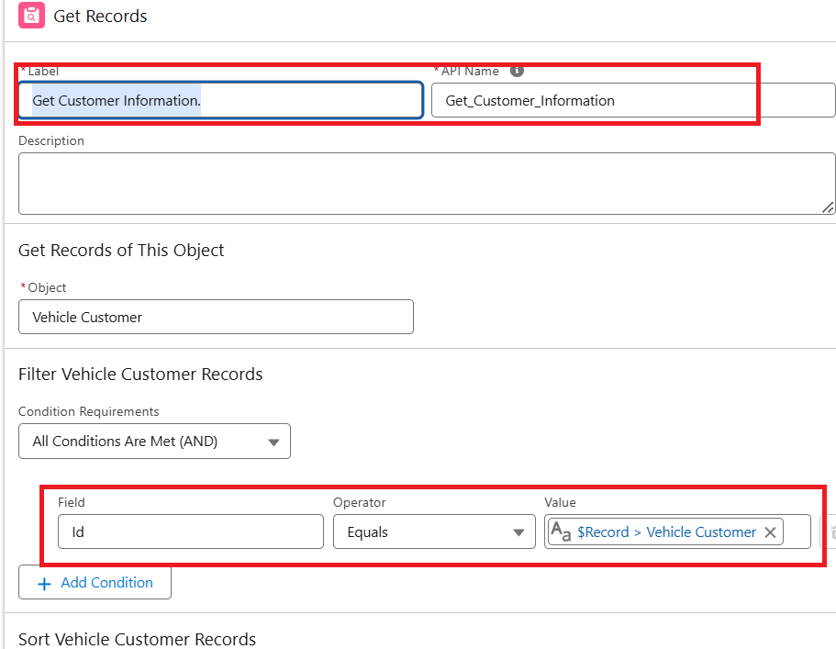

Step 7 : Click + → Select Get Records
- Label : Get Nearest Dealer
- Object : Vehicle Dealer
- Condition :
- Field : Dealer_Location c
- Operator : Equals
- Value : {!Get_Customer_Information.Address c}

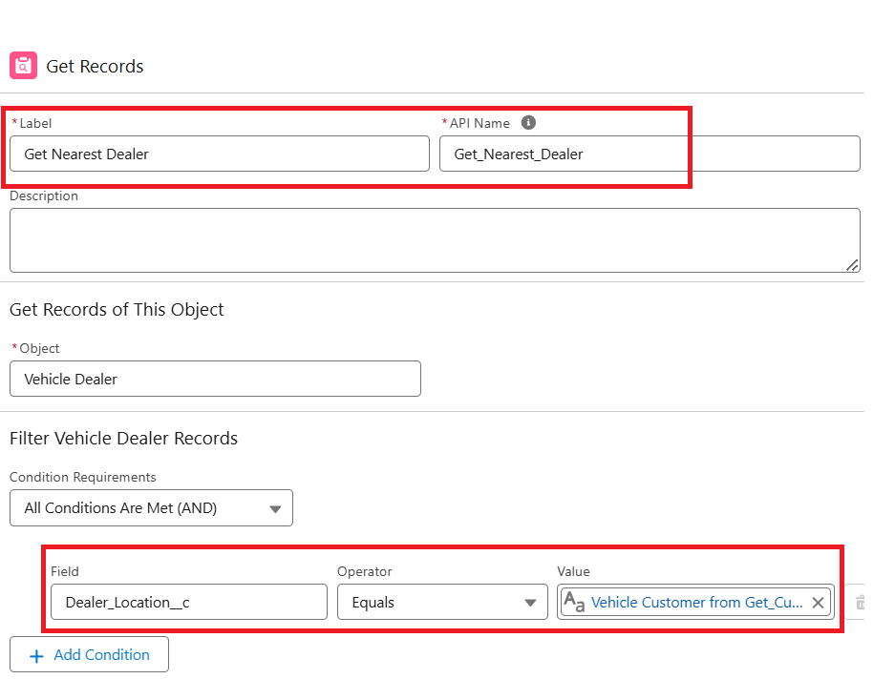

Step 8 : Click + → Select Update Records
- Label : Assign Dealer to Order
- *How to Find Records to Update and Set Their Values : Use the IDs and all field values from a record or record collection
- Select Record(s) to Update : {!Get_Nearest_Dealer}

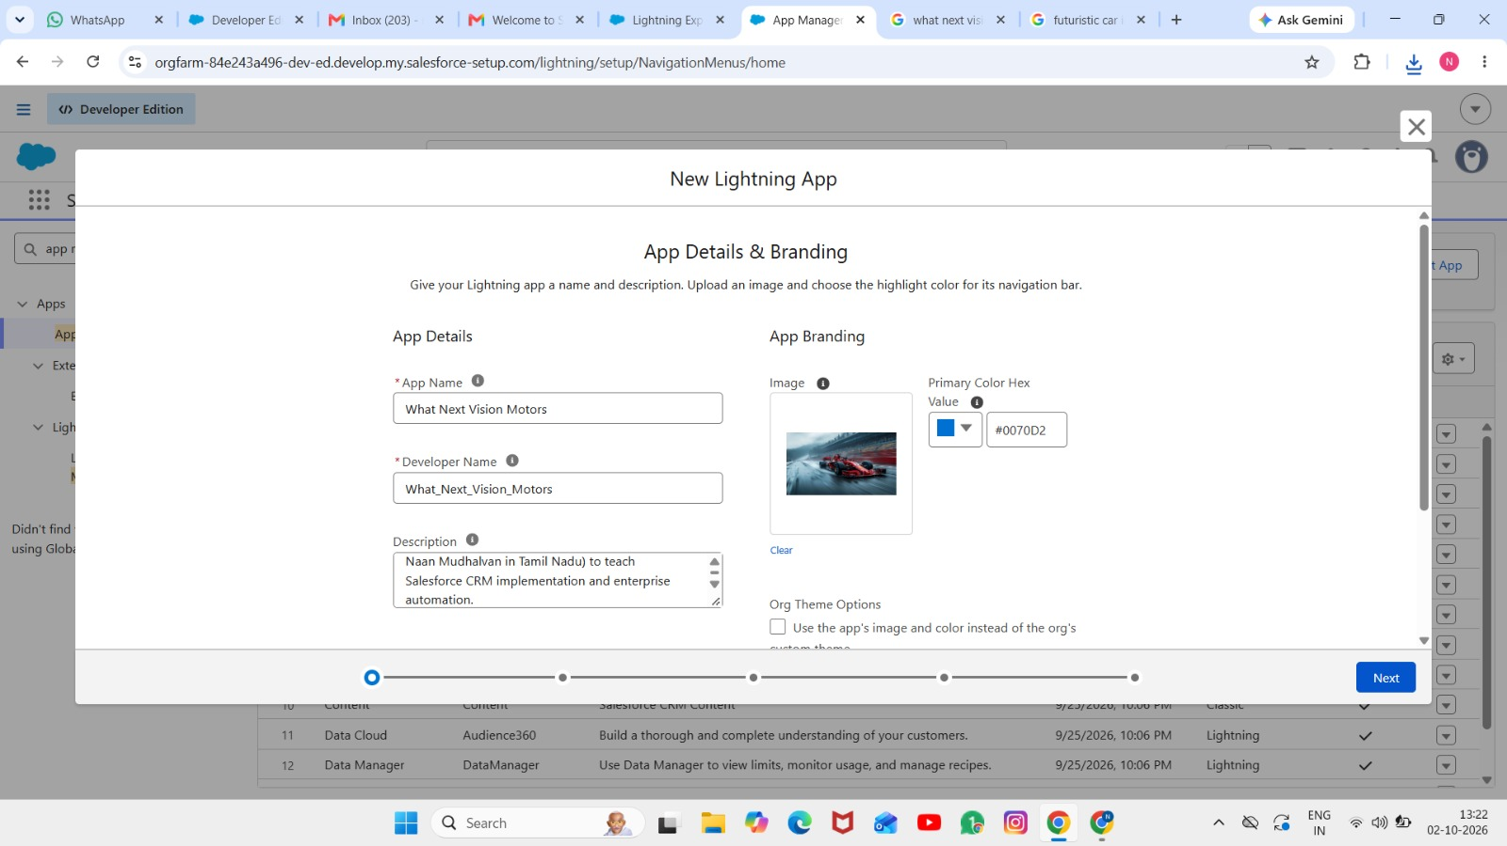

Step 9 : Click Save and Give label Name and Activate Flow.
- Label Name : Auto Assign Dealer

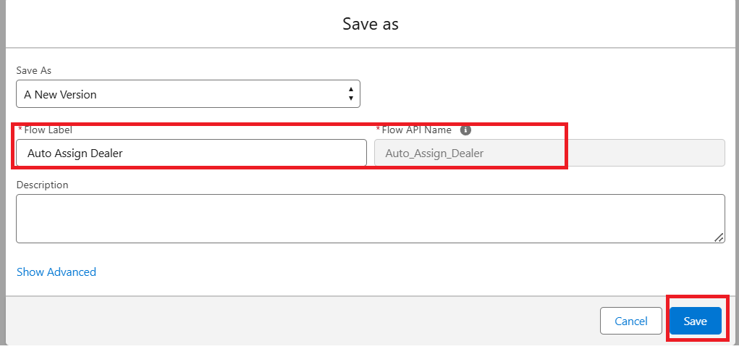

Step 10 : Activate Flow
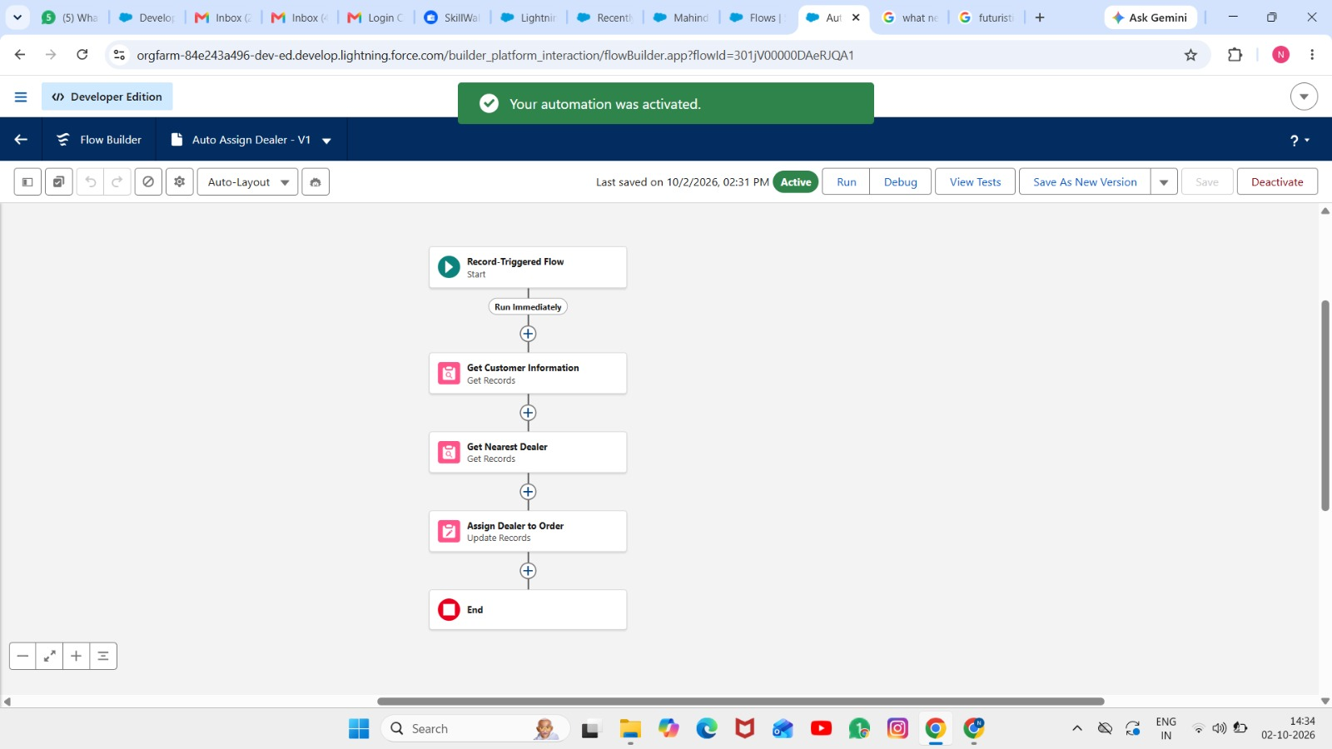

Record-Trigger Flow Creation :

Creating a record triggered flow to send an email to the customer reminding about the test drive.
Step 1 : Select Record-Triggered Flow and click Create

Step 2 : Select Vehicle Test Drive Object
Trigger the Flow When : A record is created or updated

Set Entry Condition :
- All Conditions Are Met (AND)
- Filed : Status c
- Operator : Equals
- Value : Scheduled
Step 3 : Click + Add Scheduled Paths (below the trigger).
- Label: Reminder Before Test Drive.
- Time Source: Test_Drive_Date c
- Offset Number: 1.
- Offset Options: Days Before.

- Click Done.
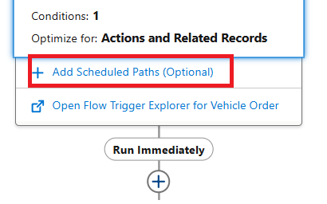

Step 4 :

- Click + Add Element → Get Records.
- Label: Get Customer Information.
- Object: Vehicle_Customer c.
- Filter Conditions: Id = {!$Record.Customer c}.
- How Many Records to Store: Select Only the first record.
- How to Store Record Data: Choose Automatically store all fields.
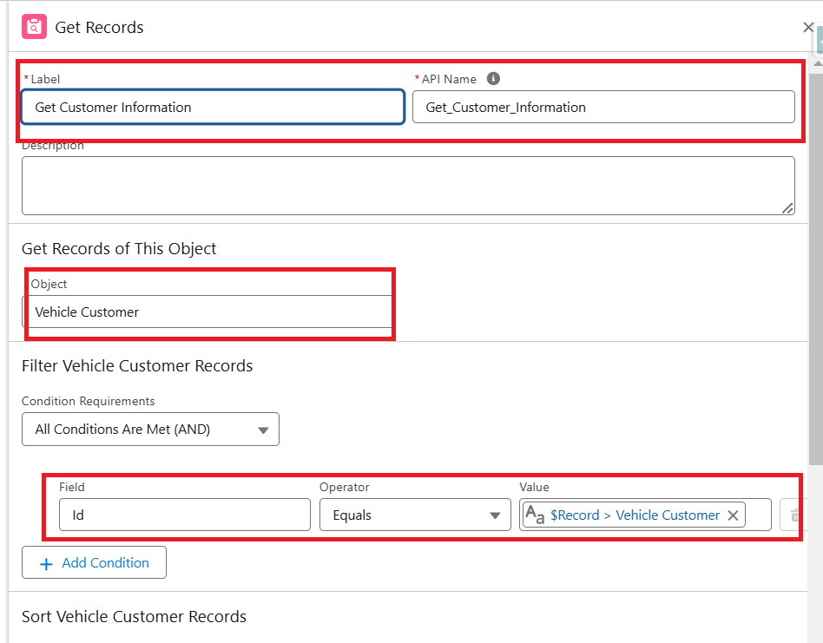

Step 5: Send Reminder Email
- Click + Add Element → Action.
- Action Type: Send Email
- Label: Send Test Drive Reminder.
- Subject: "Reminder: Your Test Drive is Tomorrow!".
- Recipient Address List : {!Get_Customer_Information.Email c}
- Rich-Text-Formatted Body : True

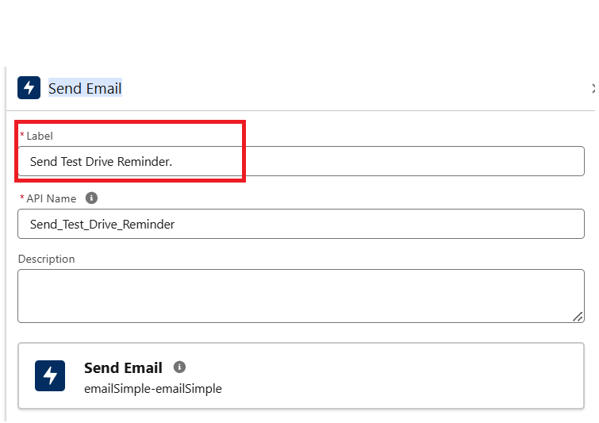

- Body : Create Variable 8 . Api Name : EmailSent

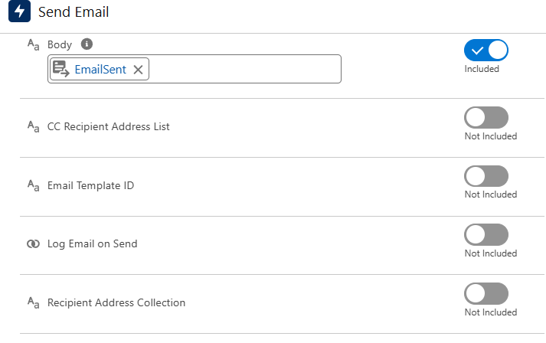

Step 6 : Click save
  - Label Name : Test Drive Reminder
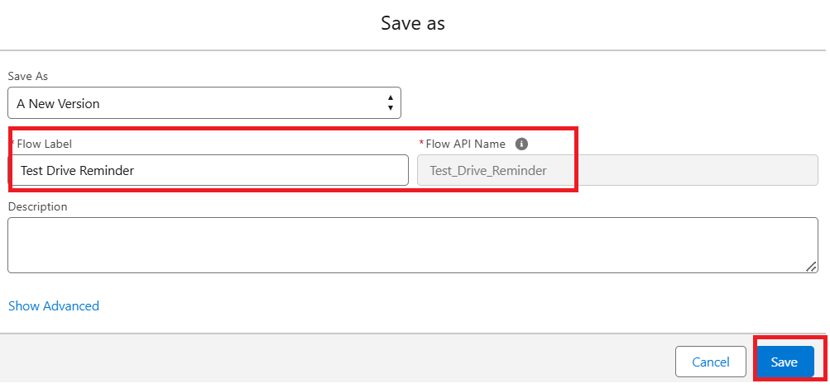

Step 7 : Activate Flow

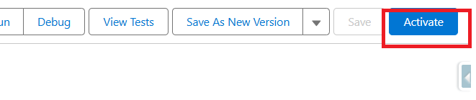

Flow Page After Creation :
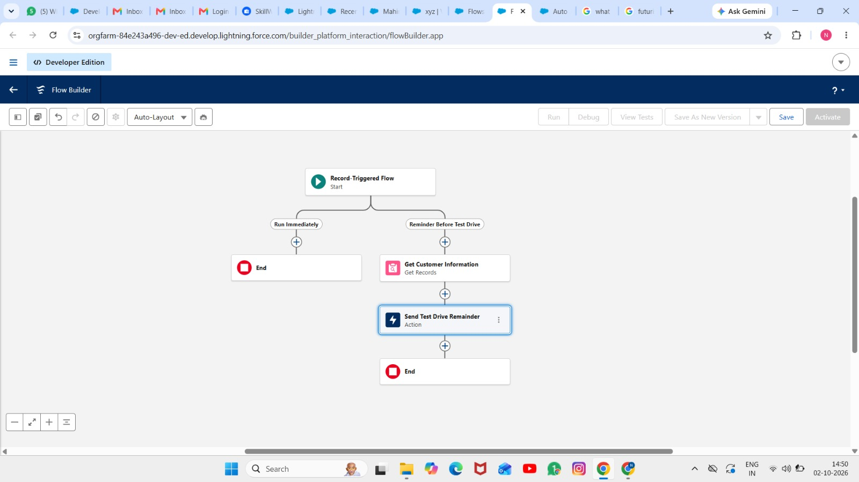

Test your Flow :

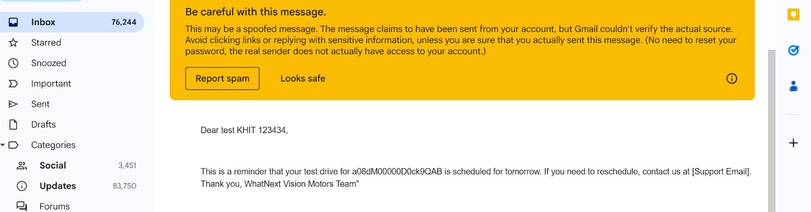
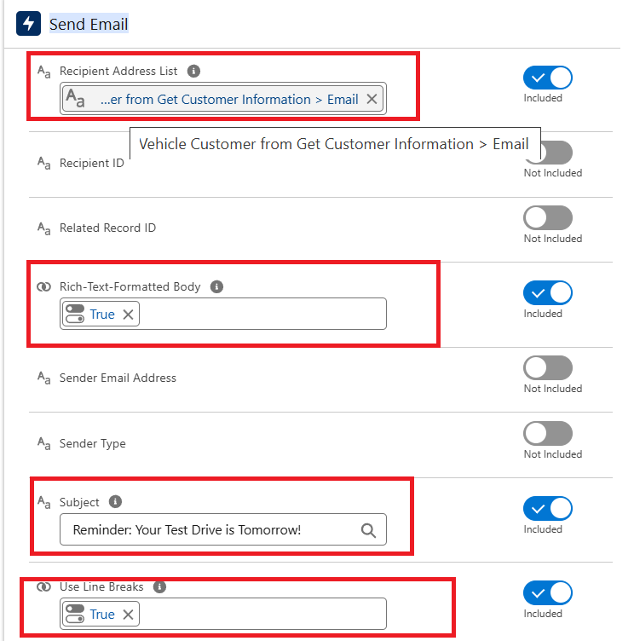

Milestone 7: Apex and Batch Class

Create Apex and Trigger Batch Jobs :
Step 1 : Click Developer Console From Gear icon
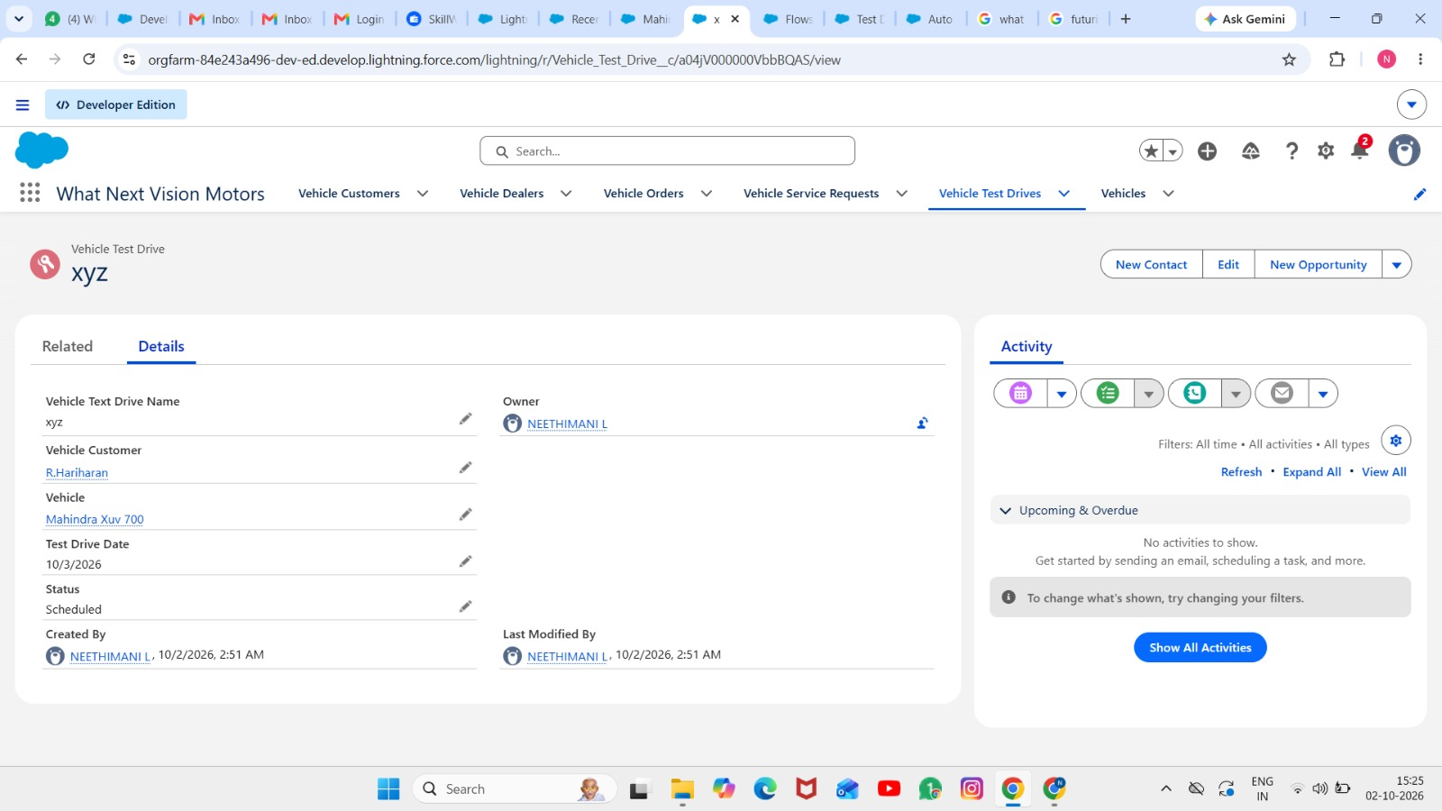

Step 2 : click File then Select New then Select Apex.

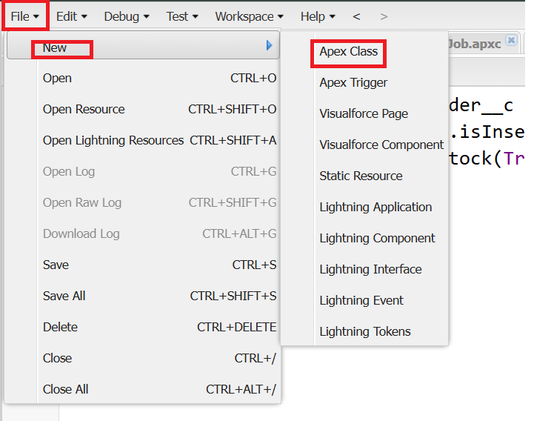

Step 3 : Give Name For Apex Class
- Class Name : VehicleOrderTriggerhandler
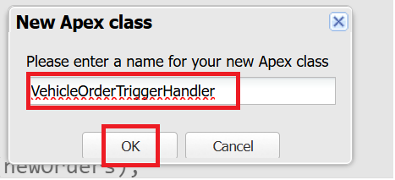

Step 4 : Write Apex Code

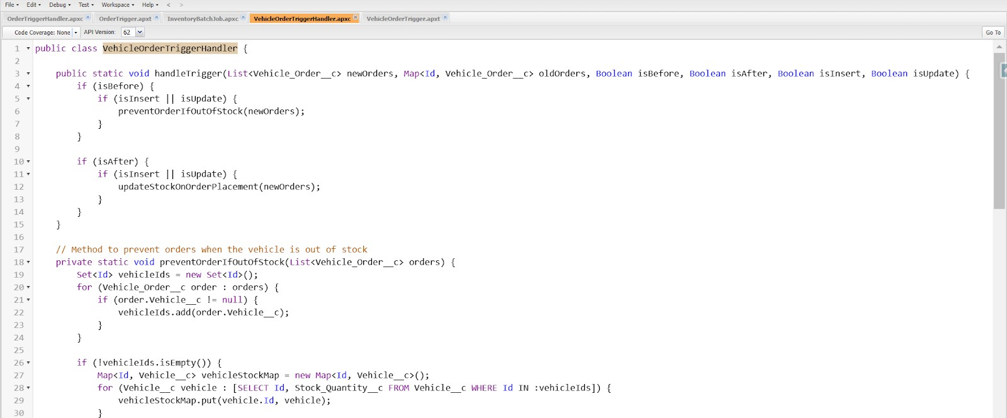
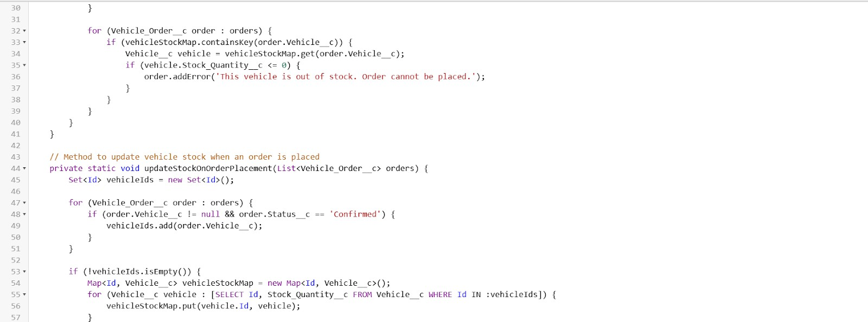
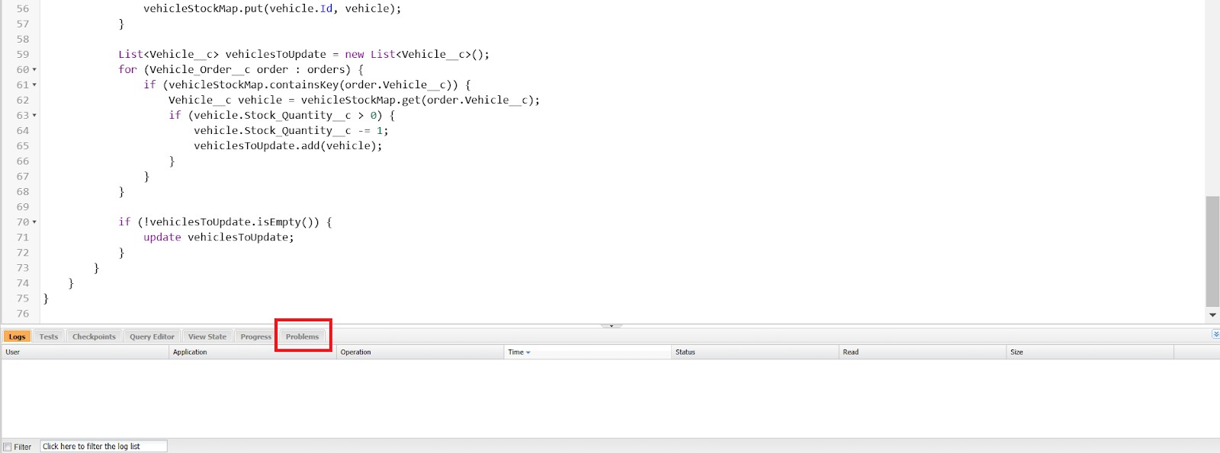

Source Code :

public class VehicleOrderTriggerHandler {

public static void handleTrigger(List<Vehicle_Order c>newOrders, Map<Id, Vehicle_Order c> oldOrders, Boolean isBefore, Boolean isAfter, Boolean isInsert, Boolean isUpdate) {
if (isBefore) {
if (isInsert || isUpdate) { preventOrderIfOutOfStock(newOrders);
}
}

if (isAfter) {
if (isInsert || isUpdate) { updateStockOnOrderPlacement(newOrders);
}
}
}
// Method to prevent orders when the vehicle is out of stock
private static void preventOrderIfOutOfStock(List<Vehicle_Order c> orders) { Set<Id>vehicleIds = new Set<Id>();
for (Vehicle_Order c order : orders) { if (order.Vehicle c != null) {
vehicleIds.add(order.Vehicle c);
}
}

if (!vehicleIds.isEmpty()) {
Map<Id, Vehicle c> vehicleStockMap = new Map<Id, Vehicle c>();
for (Vehicle c vehicle : [SELECT Id, Stock_Quantity c FROM Vehicle c WHERE Id IN :vehicleIds]) {
vehicleStockMap.put(vehicle.Id, vehicle);
}
for (Vehicle_Order c order : orders) {
if (vehicleStockMap.containsKey(order.Vehicle c)) {
Vehicle c vehicle = vehicleStockMap.get(order.Vehicle c); if (vehicle.Stock_Quantity c<= 0) {
order.addError('This vehicle is out of stock. Order cannot be placed.');
}
}
}
}
}
// Method to update vehicle stock when an order is placed
private static void updateStockOnOrderPlacement(List<Vehicle_Order c> orders) { Set<Id>vehicleIds = new Set<Id>();
for (Vehicle_Order c order : orders) {
if (order.Vehicle c != null && order.Status c == 'Confirmed') { vehicleIds.add(order.Vehicle c);
}

}
if (!vehicleIds.isEmpty()) {
Map<Id, Vehicle c> vehicleStockMap = new Map<Id, Vehicle c>();
for (Vehicle c vehicle : [SELECT Id, Stock_Quantity c FROM Vehicle c WHERE Id IN :vehicleIds]) {
vehicleStockMap.put(vehicle.Id, vehicle);
}
List<Vehicle c> vehiclesToUpdate = new List<Vehicle c>(); for (Vehicle_Order c order : orders) {
if (vehicleStockMap.containsKey(order.Vehicle c)) {
Vehicle c vehicle = vehicleStockMap.get(order.Vehicle c); if (vehicle.Stock_Quantity c>0) {
vehicle.Stock_Quantity c -= 1; vehiclesToUpdate.add(vehicle);
}
}
}
if (!vehiclesToUpdate.isEmpty()) { update vehiclesToUpdate;
}
}
}
}

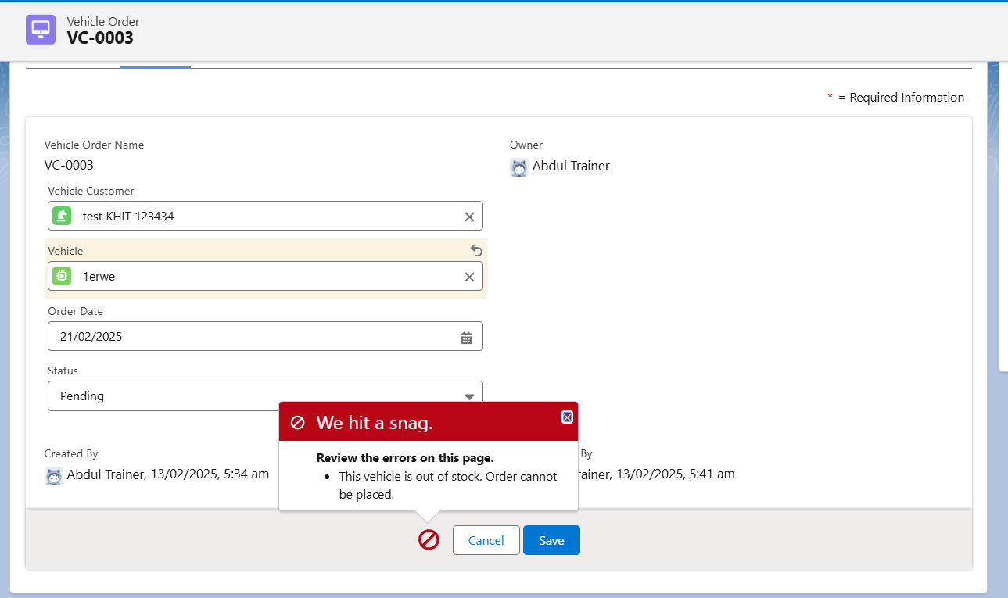

Step 5 : Write Trigger Handler

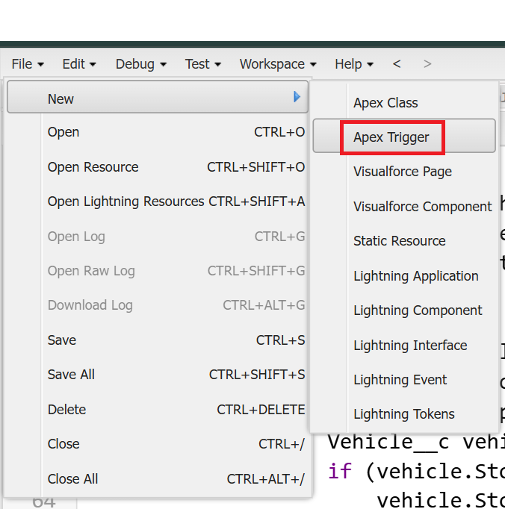

Step 6 : Writer Trigger Class Name and Select Vehicle Order Object

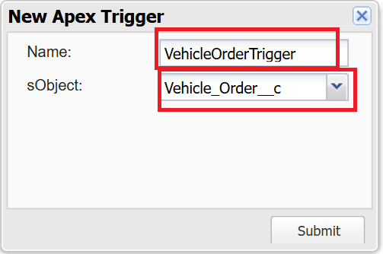

Step 7 : Call Apex Class in Trigger Class Source Code:
trigger VehicleOrderTrigger on Vehicle_Order c (before insert,before update, after insert, after update) {
VehicleOrderTriggerHandler.handleTrigger(Trigger.new, Trigger.oldMap, Trigger.isBefore,Trigger.isAfter, Trigger.isInsert, Trigger.isUpdate);
}

Step 8 : Create Batch Job
A customer places an order, but the vehicle is out of stock.
- The order remains pending.
- After new stock is added, the batch job updates the order to confirmed.

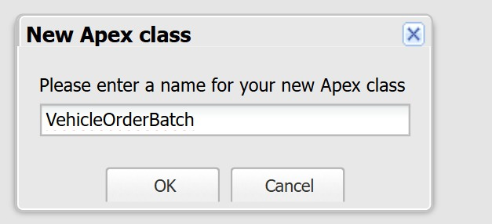
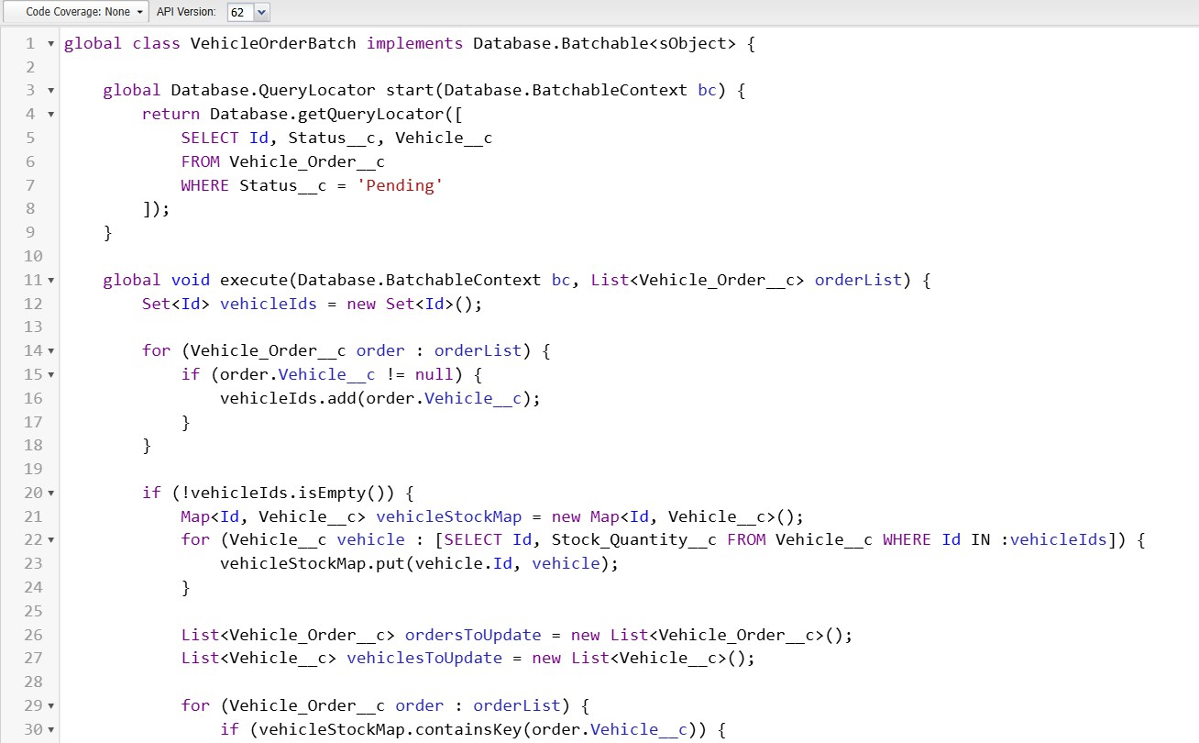

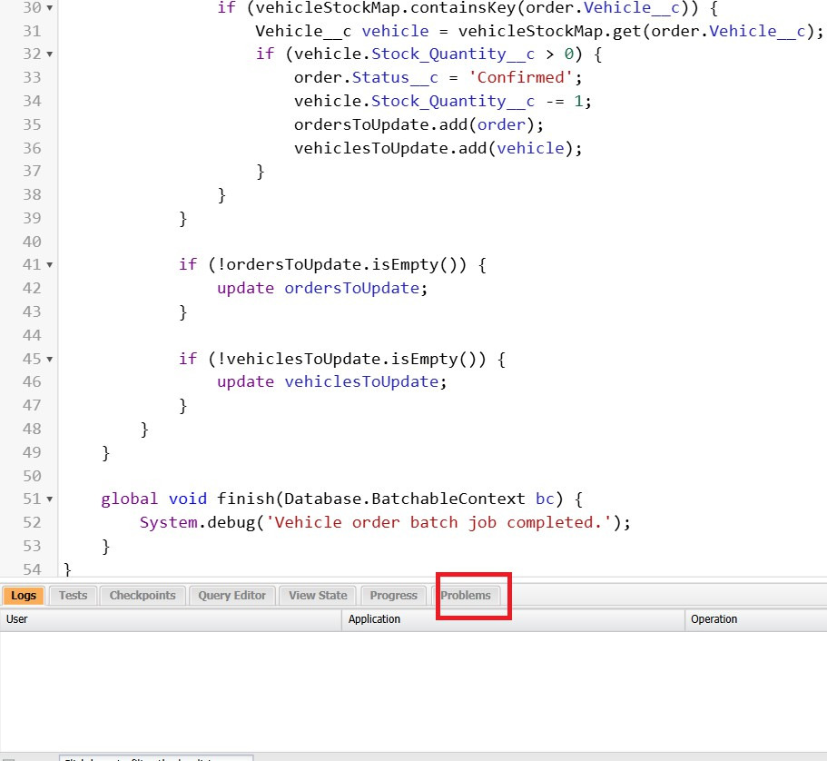

Source Code:
global class VehicleOrderBatch implements Database.Batchable<sObject> { global Database.QueryLocator start (Database.BatchableContext bc) { return Database.getQueryLocator([
SELECT Id, Status_c, Vehicle c FROM Vehicle_Order c WHERE Status c

'Pending'
]);
}
global void execute(Database.BatchableContext bc, List<Vehicle_Order_c> orderList) { Set<Id>vehicleIds = new Set<Id>();
for (Vehicle_Order_c order orderList) { if (order.Vehicle_c != null) { vehicleIds.add(order.Vehicle c);
}
}
if (!vehicleIds.isEmpty()) {
Map<Id, Vehicle c> vehicleStockMap = new Map<Id, Vehicle c>();
for (Vehicle_c vehicle: [SELECT Id, Stock Quantity_c FROM Vehicle_c WHERE Id IN vehicleIds]) {
vehicleStockMap.put(vehicle. Id, vehicle);
}
List<Vehicle_Order_c> ordersToUpdate = new List<Vehicle_Order_c>(); List<Vehicle c>vehiclesToUpdate = new List<Vehicle c>();
for (Vehicle_Order_c order orderList) {
if (vehicleStockMap.containsKey(order. Vehicle c)) { Vehicle_c vehicle = vehicleStockMap.get(order. Vehicle c); if (vehicle.Stock_Quantity c>0) {
order.Status c = 'Confirmed';

vehicle.Stock_Quantity c -= 1; ordersToUpdate.add(order); vehiclesToUpdate.add(vehicle);
}
}
}
if (!ordersToUpdate.isEmpty()) { update ordersToUpdate;
}
if (!vehicles ToUpdate.isEmpty()) { update vehiclesToUpdate;
}
}
global void finish(Database.BatchableContext bc) { System.debug('Vehicle order batch job completed.');
}
}
Step 9 : Create Schedule Class then revoked Batch Class in Schedule Class

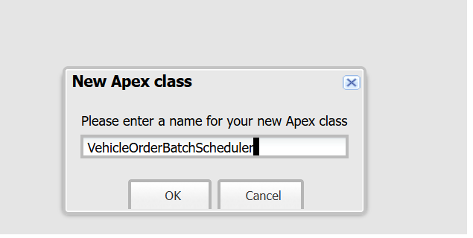
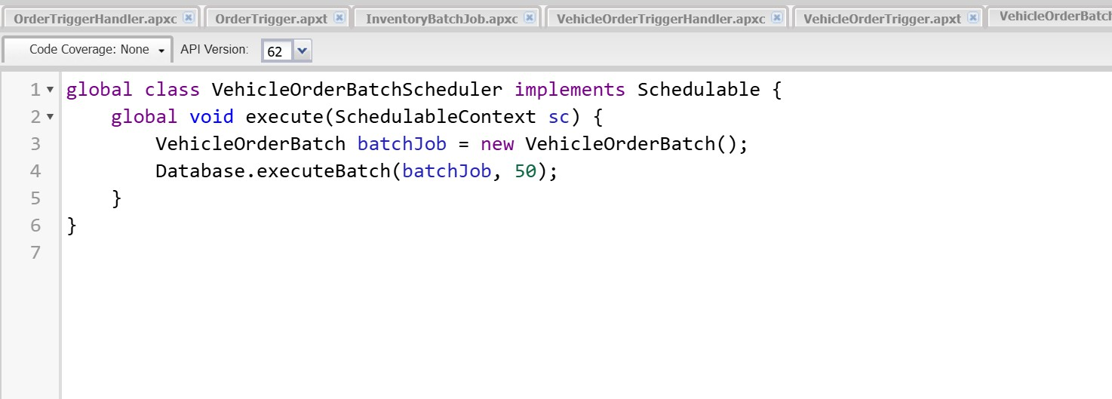

Source Code :

global class VehicleOrderBatchScheduler implements Schedulable { global void execute(SchedulableContext sc) {
VehicleOrderBatch batchJob = new VehicleOrderBatch(); Database.executeBatch(batchJob, 50); // 50 is the batch size
}
}

Step 10 : Schedule the Batch Job To run the batch job every night at midnight :
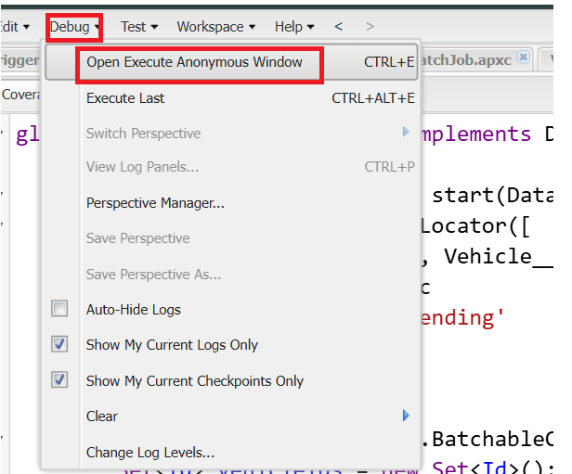
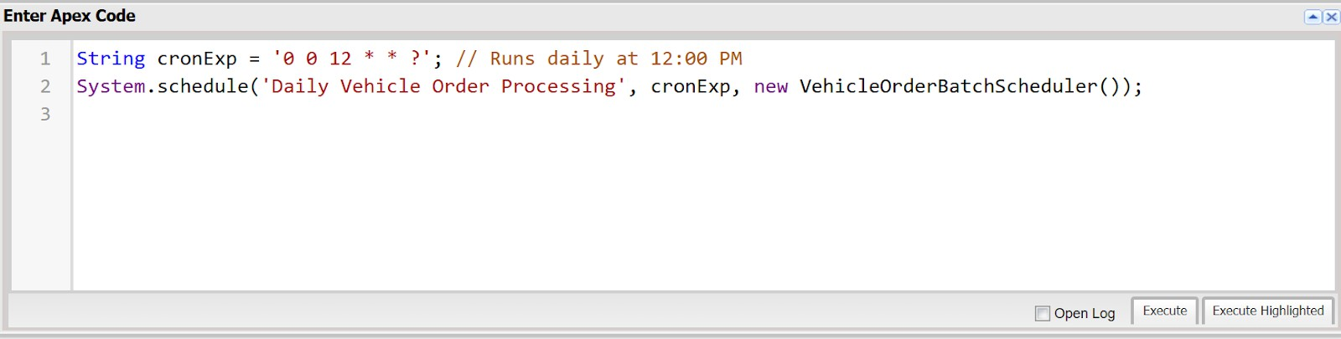

Source Code :
String cronExp = '0 0 12 * * ?'; // Runs daily at 12:00 PM

System.schedule('Daily Vehicle Order Processing', cronExp, new VehicleOrderBatchScheduler());
Step 11 : You Can Check where this Schedule Job is Running
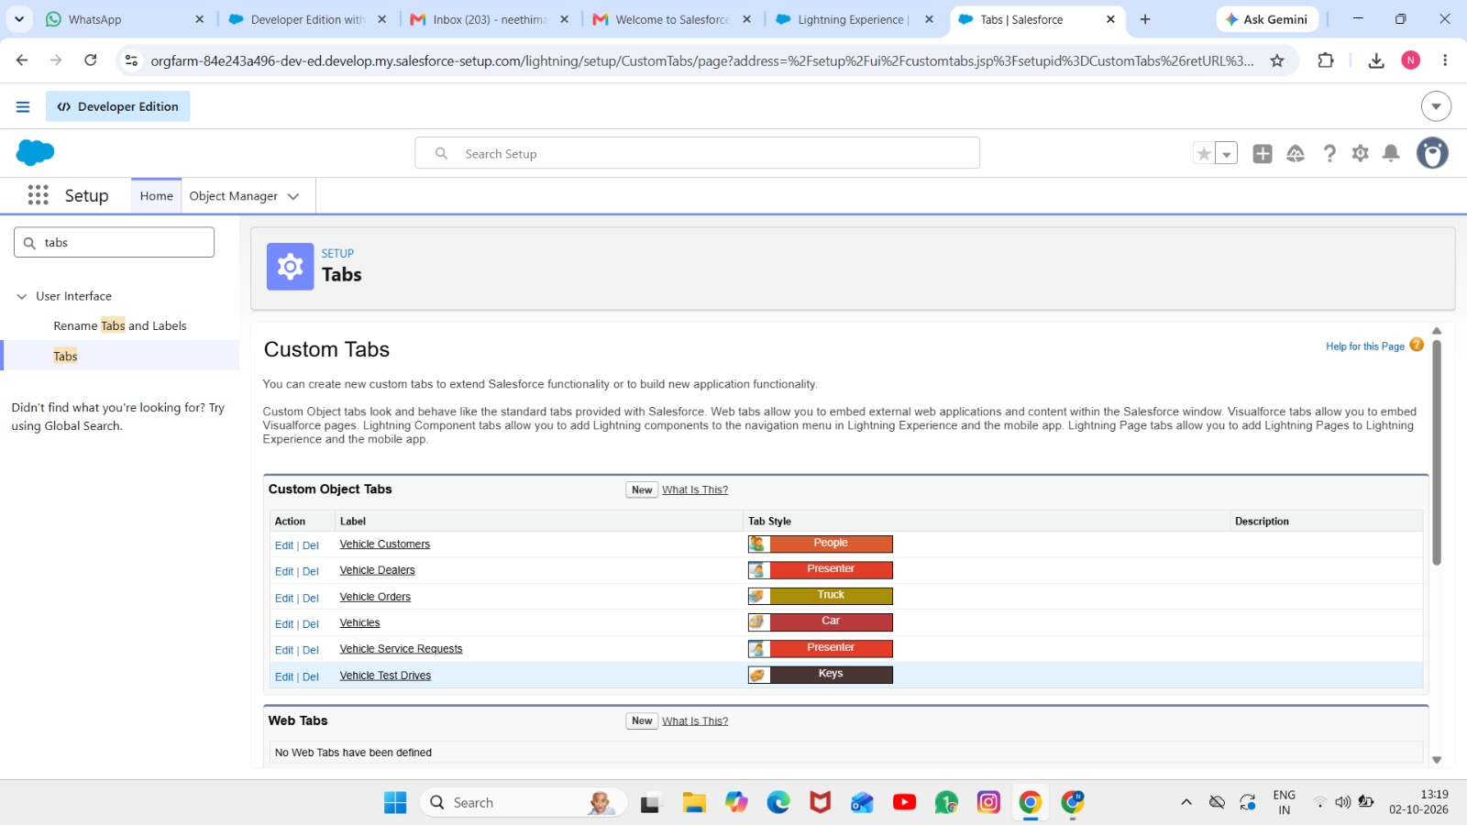

FUNCTIONAL & PERFORMANCE TESTING

During testing, screenshots were captured from Salesforce to validate vehicle creation, dealer assignment, stock validation triggers, order status updates, batch processing, scheduled reminders, and dashboard analytics. All features were verified to ensure correct functionality and performance.

ADVANTAGES & DISADVANTAGES

Advantages

  - Centralized data
  - Automated workflows
  - Real-time reporting

Disadvantages

  - Salesforce dependency
  - Requires initial configuration effort

Conclusion:

The Salesforce CRM implementation at WhatNext Vision Motors successfully modernizes vehicle ordering and dealership management. Automation improves efficiency, accuracy, and customer experience.

FUTURE SCOPE
  - Mobile ordering app
  - Dealer GPS integration
  - SMS notifications
  - AI-based demand forecasting

APPENDIX
  - Source Code: Salesforce Configuration
  - Dataset: Salesforce Objects
  - GitHub / Demo: Salesforce Developer Org

Thank You

